Parish of Aston Cantlow

NOTICE OF MEETING OF

PARISH COUNCIL

NOTICE IS HEREBY GIVEN THAT

A Meeting of the Parish Council for the above named Parish will be held in the Village Hall, Aston Cantlow on the 8th March 2018 at 7.30 p.m.

Dated this 1st day of March 2018
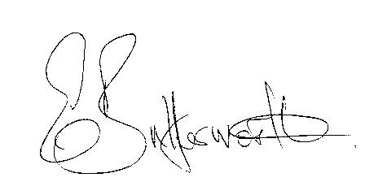Clerk

BUSINESS TO BE TRANSACTED

- Record of Members present.
- To receive apologies and approve reasons for absence.
- To receive written requests for Disclosable Pecuniary Interests where that interest is not already in the register of members’ interests.
- To approve the minutes of the parish council meeting held on 11th January 2018.
- Public participation: To receive any questions or presentations from the public.
- County & District Councillors reports. For information only. Unless known in advance items raised for a decision will appear on the next agenda.
- Planning Matters – update on current planning matters and to discuss methods of responding to planning applications.
- Progress reports – for information only and are items not on the agenda.
- Correspondence received:
- Site Allocations Plan for Stratford on Avon District – Intention to Prepare a Local Plan.
- AL86 Definitive map amendment notification.
- World War 1 Centenary Celebrations.
- Community Infrastructure Levy (CIL) Training for Parish Councillors – video of a training session available on the SDC website.
- Notification of Review of Ethical Standards in Local Government.
- Advisory on new booking and heating systems for the Village Hall.
- Request from a resident to put Aston Cantlow forward for Village of the Year.
- Parish Plan progress.
- E5341
- Aston Cantlow Children’s Playground: To consider a request from the Village Hall Trustees for the Parish Council to take over full responsibilities for the playground
- New external auditor appointments.
- New Data Protection Laws guidance and requirements.
- Consultation: Canal Quarter Regeneration Zone Framework Masterplan Supplementary planning document.
- Lengthsman Scheme update.
- Defibrillator update.
- Website progress on upgrade.
- Parish Council events 2018.
- Payment of outstanding invoices.
- Councillors’ reports and items for the agenda for the next meeting. Cllrs. are reminded that this is not an opportunity for decision making.
- Date of next meeting: 12th April 2018. Annual Parish meeting followed by ordinary Parish Council meeting.

