Parish of Aston Cantlow

NOTICE OF MEETING OF

PARISH COUNCIL

NOTICE IS HEREBY GIVEN THAT

A Meeting of the Parish Council for the above named Parish will be held in The Guild Hall, Aston Cantlow on the 9th March 2017 at 7.30 p.m.

Dated this 2nd day of March 2017
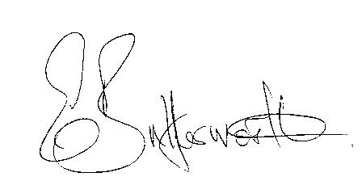Clerk

BUSINESS TO BE TRANSACTED

- Record of Members present.
- To receive apologies and approve reasons for absence.
- To receive written requests for Disclosable Pecuniary Interests where that interest is not already in the register of members’ interests.
- To approve the minutes of the meeting held on 9th February 2017.
- Public participation: To receive any questions or presentations from the public.
- County & District Councillors reports. For information only. Unless known in advance items raised for a decision will appear on the next agenda.
- Planning Matters – update on current planning applications.
To consider Planning Application No. 17/00610/COUQ Barn Salters Lane: Prior approval notification for the proposed change of use of agricultural building to 1 dwellinghouse, associated curtilage and building operations (Class Qa and Qb).
- Progress reports – for information only and are items not on the agenda.
- Correspondence received:
- A guide to preparing for Emergencies in Warwickshire
- Details of White Paper “Fixing our broken housing market”.
- Scam Alert – workmen charging a fortune to remove moss from roofs.
- WALC notification of S137 limits for 2017-18
- Parish Plan status.
- E5341 update.
- Millenium plaque status.
- Lengthsman Scheme progress report.
- Defibrillator – progress report.
- Website - progress report
- Payment of outstanding invoices.
- Councillors’ reports and items for the agenda for the next meeting. Cllrs. are reminded that this is not an opportunity for decision making.
- Date of next meeting: 12th April 2017. Annual Parish Meeting followed by ordinary Parish Council meeting.

