Parish of Aston Cantlow

NOTICE OF MEETING OF

PARISH COUNCIL

NOTICE IS HEREBY GIVEN THAT

A Meeting of the Parish Council for the above named Parish will be held in The Guild Hall, Aston Cantlow on the 9th April 2015 at 7.30 p.m. following the Annual Parish Meeting.

Dated this 1st day of April 2015
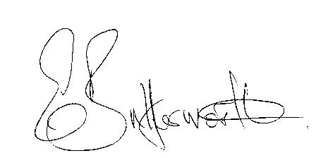Clerk

BUSINESS TO BE TRANSACTED

- Record of Members present.
- To receive apologies and approve reasons for absence.
- To receive written requests for Disclosable Pecuniary Interests where that interest is not already in the register of members’ interests.
- To approve the minutes of the meetings held on 15th January and 19th March 2015.
- Public participation: To receive any questions or presentations from the public.
- County Councillor report. For information only. Unless known in advance items raised for a decision will appear on the next agenda.
- Planning Matters – update on current planning applications.
Consider Planning Application Nos. 15/00703/LBC & 15/00702/FUL Swallow Cottage, Burford Lane, Shelfield: Repair of existing boundary wall and fence (requires demolition and rebuild). Repair of existing external steps to patio/pathway (requires demolition and rebuild).
- Progress reports – for information only and are items not on the agenda.
- Correspondence received:
- WRCC: Affordable Rural Housing: A practical guide for Parish Councils.
- CSW Broadband Update - Voucher Scheme Launch March 2015.
- County Councillor: Delegated Road Safety Budget.
- To consider S137 grants for the current financial year.
- Parish Plan update.
- Review of Asset Register.
- Playground: Complaints to Village Hall Committee regarding unacceptable behaviour of children from the village in and around that area.
- To consider priorities and actions required prior to the elections in May.
- To review the Clerk’s hours of work.
- Payment of outstanding invoices.
- Councillors’ reports and items for the agenda for the next meeting. Each Cllr. is requested to use this opportunity to report on minor matters for information not included elsewhere on the agenda and to raise items for future agendas. Cllrs. are reminded that this is not an opportunity for decision making.
- Date of next meeting: 21st May 2015. Annual General Meeting followed by ordinary Parish Council meeting.

