Parish of Aston Cantlow

NOTICE OF MEETING OF

PARISH COUNCIL

NOTICE IS HEREBY GIVEN THAT

A Meeting of the Parish Council for the above named Parish will be held in The Guild Hall, Aston Cantlow on the 9th June 2016 at 7.30 p.m.

Dated this 3rd day of June 2016
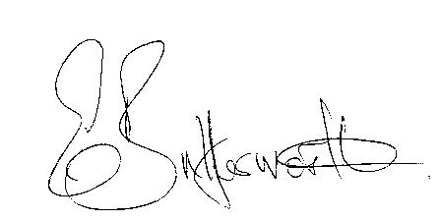Clerk

BUSINESS TO BE TRANSACTED

- Record of Members present.
- To receive apologies and approve reasons for absence.
- To receive written requests for Disclosable Pecuniary Interests where that interest is not already in the register of members’ interests.
- To approve the minutes of the Annual General Meeting and ordinary meeting held on 12th May 2016.
- Public participation: To receive any questions or presentations from the public.
- County & District Councillors reports. For information only. Unless known in advance items raised for a decision will appear on the next agenda.
- Planning Matters – update on current planning applications.
- Progress reports – for information only and are items not on the agenda.
- Correspondence received:
- Community Payback scheme contact details.
- E02-16 - NALC and SLCC Salary Scales 2016-18 Final.
- Government document concerning Fly Tipping.
- Parish Plan Update – Progress report.
- Parish Council Activities review.
- Discussion regarding need for a defibrillator in Aston Cantlow.
- Lengthsman Scheme.
- Consideration of Section 137 Grants.
- Payment of outstanding invoices.
- Councillors’ reports and items for the agenda for the next meeting. Cllrs. are reminded that this is not an opportunity for decision making.
- Date of next meeting: 10th August 2016.

