Parish of Aston Cantlow

NOTICE OF MEETING OF

PARISH COUNCIL

NOTICE IS HEREBY GIVEN THAT

A Meeting of the Parish Council for the above named Parish will be held in The Guild Hall, Aston Cantlow on the 9th October 2014 at 7.30 p.m.

Dated this 2nd day of October 2014
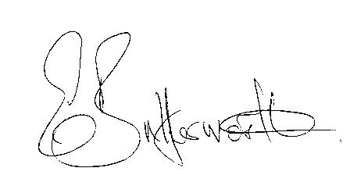Clerk

BUSINESS TO BE TRANSACTED

- Record of Members present.
- To receive apologies and approve reasons for absence.
- To receive written requests for Disclosable Pecuniary Interests where that interest is not already in the register of members’ interests.
- To approve the minutes of the meeting held on 11th September 2014.
- Public participation: To receive any questions or presentations from the public.
- District & County Councillor reports. For information only. Unless known in advance items raised for a decision will appear on the next agenda.
- Planning Matters – update on current planning applications.
To consider application No. 14/02482/AGNOT Pools Barn Farm, Little Alne:
Notification for prior approval of extension to an agricultural building.
- Progress reports – for information only and are items not on the agenda.
- Correspondence received:
-WRCC - Housing Needs Survey.
-CSW Broadband Update- September 2014.
- Parish Plan update.
- To consider S137 grants for the current financial year.
- Payment of outstanding invoices.
- Councillors’ reports and items for the agenda for the next meeting. Each Cllr. is requested to use this opportunity to report on minor matters for information not included elsewhere on the agenda and to raise items for future agendas. Cllrs. are reminded that this is not an opportunity for decision making.
- Date of next meeting: 20th November 2014.

