Parish of Aston Cantlow

NOTICE OF MEETING OF

PARISH COUNCIL

NOTICE IS HEREBY GIVEN THAT

A Meeting of the Parish Council for the above named Parish will be held in the Village Hall, Aston Cantlow on the 9th November 2017 at 7.30 p.m.

Dated this 2nd day of November 2017
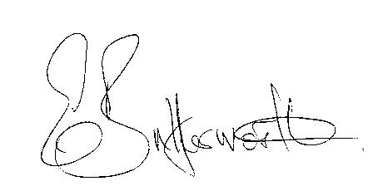Clerk

BUSINESS TO BE TRANSACTED

- Record of Members present.
- To receive apologies and approve reasons for absence.
- To receive written requests for Disclosable Pecuniary Interests where that interest is not already in the register of members’ interests.
- To approve the minutes of the parish council meeting held on 12th October 2017.
- Public participation: To receive any questions or presentations from the public.
- County & District Councillors reports. For information only. Unless known in advance items raised for a decision will appear on the next agenda.
- Planning Matters – update on current planning applications.
- Progress reports – for information only and are items not on the agenda.
- Correspondence received:
- Temporary closure of C39 Whitehouse Hill, Little Alne 20th November to 1st December.
- Request for information relating to existence, position, width or status of the AL86.
- Consultation document on the Local Government finance settlement for 2018-19
- Parish Plan status.
- Revised Standing Orders for consideration.
- Assets survey report.
- E5341 current position.
- Social media- to consider a proposal document from Cllr. Berry
- Lengthsman Scheme – to consider proposed works suggested by Councillors.
- Defibrillator – current status
- Website – to consider input from Councillors to the draft specification
- Payment of outstanding invoices.
- Councillors’ reports and items for the agenda for the next meeting. Cllrs. are reminded that this is not an opportunity for decision making.
- Date of next meeting: 11th January 2018.

