Parish of Aston Cantlow

NOTICE OF MEETING OF

PARISH COUNCIL

NOTICE IS HEREBY GIVEN THAT

A Meeting of the Parish Council for the above named Parish will be held in the Village Hall, Aston Cantlow on the 10th May 2018 following the Annual General Meeting.

Dated this 3rd day of May 2018
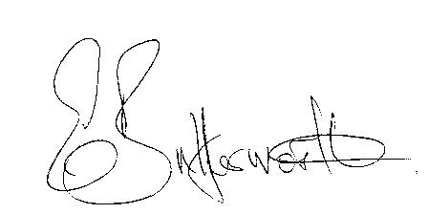Clerk

BUSINESS TO BE TRANSACTED

- Record of Members present.
- To receive apologies and approve reasons for absence.
- To receive written requests for Disclosable Pecuniary Interests where that interest is not already in the register of members’ interests.
- To approve the minutes of the parish council meetings held on 12th April 2018.
- Public participation: To receive any questions or presentations from the public.
- County & District Councillors reports. For information only. Unless known in advance items raised for a decision will appear on the next agenda.
- Planning Matters – update on current planning matters.
Consideration of the following planning application: 18/01009/FUL Pools Barn Farm, Little Alne: Erection of a 6,000Tonne (1,455 square metre) combinable crop store (extension to existing crop store) and associated hard standing and landscaping.
- Progress reports – for information only and are items not on the agenda.
- Correspondence received:
- Request for a Parish Councillor to take up the role of Parish Council representative on the Village Hall Committee.
- Information Commissioner’s Office Statement on the General Data Protection Regulation.
- WALC notification of revised pay-scales to be implemented from 1st April 2018.
- Notice of Modification Order AL86 for information.
- Aston Cantlow Children’s Playground
- New Data Protection Laws guidance and requirements: information update from Cllr. Wallis.
- Website progress report on upgrade.
- Parish Council events 2018 – progress to date.
- Annual Accounts 2017/18.
- Councillors’ reports and items for the agenda for the next meeting. Cllrs. are reminded that this is not an opportunity for decision making.
- Date of next meeting: 14th June 2018.

