Parish of Aston Cantlow

NOTICE OF MEETING OF

PARISH COUNCIL

NOTICE IS HEREBY GIVEN THAT

A Meeting of the Parish Council for the above named Parish will be held in The Guild Hall, Aston Cantlow on the 10th July 2014 at 7.30 p.m.

Dated this 4th day of July 2014
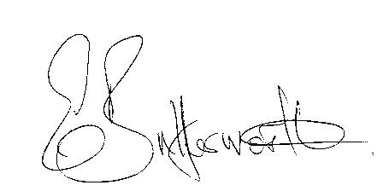Clerk

BUSINESS TO BE TRANSACTED

- Record of Members present.
- To receive apologies and approve reasons for absence.
- To receive written requests for Disclosable Pecuniary Interests where that interest is not already in the register of members’ interests.
- To approve the minutes of the meeting held on 15th May 2014.
- Public participation: To receive any questions or presentations from the public.
- District & County Councillor reports. For information only. Unless known in advance items raised for a decision will appear on the next agenda.
- Planning Matters – update on current planning applications:
- Progress reports – for information only and are items not on the agenda.
- Correspondence received:
- CSW Broadband Newsletter – June 2014
- Consultation:
- Stratford on Avon District Proposed Submission Core Strategy
- Proposed actions relating to flood alleviation.
- To discuss and agree what the role of the Parish Council is and what interventions we should take.
- To approve payment of outstanding invoices.
- Councillors’ reports and items for the agenda for the next meeting. Each Cllr. is requested to use this opportunity to report on minor matters for information not included elsewhere on the agenda and to raise items for future agendas. Cllrs. are reminded that this is not an opportunity for decision making.
- Date of next meeting: 11th September 2014.

