Parish of Aston Cantlow

NOTICE OF MEETING OF

PARISH COUNCIL

NOTICE IS HEREBY GIVEN THAT

A Meeting of the Parish Council for the above named Parish will be held in The Guild Hall, Aston Cantlow on the 10th August 2016 at 7.30 p.m.

Dated this 4th day of August 2016
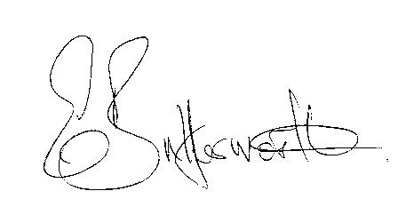Clerk

BUSINESS TO BE TRANSACTED
- Record of Members present.
- To receive apologies and approve reasons for absence.
- To receive written requests for Disclosable Pecuniary Interests where that interest is not already in the register of members’ interests.
- To approve the minutes of the meeting held on 9th June 2016.
- Public participation: To receive any questions or presentations from the public.
- County & District Councillors reports. For information only. Unless known in advance items raised for a decision will appear on the next agenda.
- Planning Matters – update on current planning applications.
To consider the following applications:
Planning Application No. 16/02035/FUL Badbury Hill Barn, Shelfield: Extension to residential barn.
Planning Application No. 16/02105/FUL Reid Barn, Aston Cantlow: construction of an oak framed extension to rear.
- Progress reports – for information only and are items not on the agenda.
- Correspondence received:
- Big Lottery Fund - Awards For All (Lottery Grants of between 300 and 10,000).
- Stratford District Core Strategy–Publication of Inspector’s final report.
- Flying a Flag for Commonwealth Day 2017.
- Warwickshire County Councillors Grant Fund 2016/17.
- Parish Plan – to consider adoption of the final plan.
- Consultations:
Mayoral West Midlands Combined Authority, Functions Scheme
Police and Crime Panel Consultation
Warwickshire PCC: policing and community safety consultation.
- Parish Council Activities review.
- Continued discussion regarding need for a Defibrillator in Aston Cantlow.
- Lengthsman Scheme update.
- Consideration of Section 137 Grants.
- Payment of outstanding invoices.
- Councillors’ reports and items for the agenda for the next meeting. Cllrs. are reminded that this is not an opportunity for decision making.
- Date of next meeting: 15th September 2016.

