Parish of Aston Cantlow

NOTICE OF MEETING OF

PARISH COUNCIL

NOTICE IS HEREBY GIVEN THAT

A Meeting of the Parish Council for the above named Parish will be held in The Guild Hall, Aston Cantlow on the 10th September 2015 at 7.30 p.m.

Dated this 3rd day of September 2015
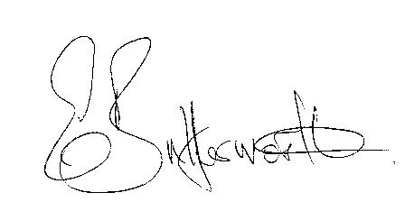Clerk

BUSINESS TO BE TRANSACTED

- Record of Members present.
- To receive apologies and approve reasons for absence.
- To receive written requests for Disclosable Pecuniary Interests where that interest is not already in the register of members’ interests.
- To approve the minutes of the meetings held on 25th June 2015.
- Public participation: To receive any questions or presentations from the public.
- County & District Councillors reports. For information only. Unless known in advance items raised for a decision will appear on the next agenda.
- Planning Matters – update on current planning applications and to consider the following Planning applications:
Application Nos. 15/02567/LBC and 15/02572/FUL The Olde Barn, Shelfield: Conversion of store building and part of garage block to two separate holiday lets.
- Progress reports – for information only and are items not on the agenda.
- Correspondence received:
- Distance Learning Modules, a wealth of information for Councillors at all levels.
- Warwickshire County Council Lengthsman Scheme – expressions of interest requested by
the end of September 2015.
- Combined Authorities Consultation – deadline 24th July 2015.
- Invitation to Stratford District Council Chairman’s Civic Service 27th September 2015.
- Independent Advisory Groups – Critical Friends of the Police.
- To consider S137 grants for the current financial year.
- To agree Parish Council procedures for the new term.
- Parish Plan update.
- Bank Mandate to be updated.
- Payment of outstanding invoices.
- Councillors’ reports and items for the agenda for the next meeting. Cllrs. are reminded that this is not an opportunity for decision making.
- Date of next meeting: 8th October 2015.

