Parish of Aston Cantlow

NOTICE OF MEETING OF

PARISH COUNCIL

NOTICE IS HEREBY GIVEN THAT

A Meeting of the Parish Council for the above named Parish will be held in The Guild Hall, Aston Cantlow on the 10th November 2016 at 7.30 p.m.

Dated this 3rd day of November 2016
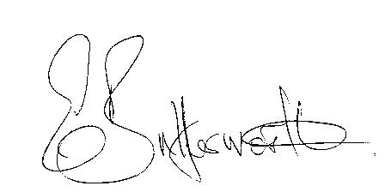Clerk

BUSINESS TO BE TRANSACTED

- Record of Members present.
- To receive apologies and approve reasons for absence.
- To receive written requests for Disclosable Pecuniary Interests where that interest is not already in the register of members’ interests.
- To approve the minutes of the meeting held on 13th October 2016.
- Public participation: To receive any questions or presentations from the public.
- County & District Councillors reports. For information only. Unless known in advance items raised for a decision will appear on the next agenda.
- Planning Matters – update on current planning applications.
- Progress reports – for information only and are items not on the agenda.
- Correspondence received:
- BT programme of intended public payphone removals.

- Footpath & bridleway maintenance work – enquiry from a resident.
- A resident’s report about public footpath defects – AL173.
- Resident report of damaged/displaced manhole cover on Brook Road.
- Resident report of tarmac sinking where work carried out to install BT cabinet by Village Hall, possible water leak in Mill Lane.
- Parish Plan – to discuss feedback and agree any changes resulting from SDC consultation.
- Draft Precept.
- S137 grants.
- E5341 – closure notices.
- Lengthsman Scheme progress report.
- Defibrillator – update.
- Parish Council events.
- Asset Register – progress report.
- Payment of outstanding invoices.
- Councillors’ reports and items for the agenda for the next meeting. Cllrs. are reminded that this is not an opportunity for decision making.
- Date of next meeting: 12th January 2017

