Parish of Aston Cantlow

NOTICE OF MEETING OF

PARISH COUNCIL

NOTICE IS HEREBY GIVEN THAT

A Meeting of the Parish Council for the above named Parish will be held in the Village Hall, Aston Cantlow on the 11th January 2018 at 7.30 p.m.

Dated this 4th day of January 2018
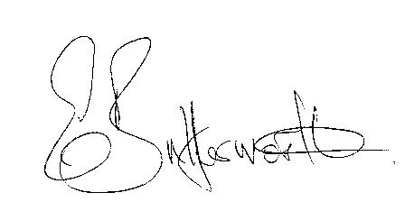Clerk

BUSINESS TO BE TRANSACTED

- Record of Members present.
- To receive apologies and approve reasons for absence.
- To receive written requests for Disclosable Pecuniary Interests where that interest is not already in the register of members’ interests.
- To approve the minutes of the parish council meeting held on 9th November 2017.
- Public participation: To receive any questions or presentations from the public.
- County & District Councillors reports. For information only. Unless known in advance items raised for a decision will appear on the next agenda.
- Planning Matters – update on current planning matters and to discuss methods of responding to planning applications.
- Progress reports – for information only and are items not on the agenda.
- Correspondence received:
- Refurbished rural community computers available at reasonable cost.
- Report from resident that the broken BT frame and cover on The Green has not yet been repaired.
- Enquiry from resident if training will be available for use of the defibrillator and concern about the poor phone signals in the village should the code for the defibrillator need to be obtained.
- Request for nominations for attendance at a Royal Garden Party at Buckingham Palace.
- The Chairman received a telephone enquiry from a gentleman enquiring what the Parish Council’s views would be regarding development of Amenity land.
- The Clerk received a request from a resident who lives on the road to Shelfield, to enquire whether this road can be added to the gritting routes.
- Parish Plan. Approval of the action plan circulated after the November meeting.
- SDC adoption of new Councillor Code of Conduct for consideration.
- Precept request for 2018/19.
- E5341 current position.
- Consideration of grant towards playground repairs/replacements providing the requested information is available.
- Junction of B4089/C39 – measures to reduce danger at this junction.
- Lengthsman Scheme – progress on items put forward for action at the last meeting.
- Defibrillator – current status.
- Grit bins – to consider whether any are required for the parish.
- Website – to consider quotations for upgrading.
- Payment of outstanding invoices.
- Councillors’ reports and items for the agenda for the next meeting. Cllrs. are reminded that this is not an opportunity for decision making.
22. Date of next meeting: 15th February 2018.

