Parish of Aston Cantlow

NOTICE OF MEETING OF

PARISH COUNCIL

NOTICE IS HEREBY GIVEN THAT

A Meeting of the Parish Council for the above named Parish will be held in The Guild Hall, Aston Cantlow on the 11th February 2016 at 7.30 p.m.

Dated this 4th day of February 2016
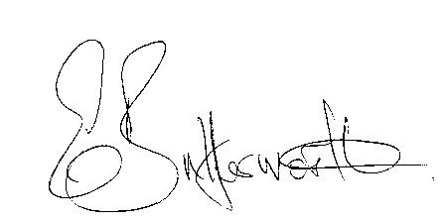Clerk

BUSINESS TO BE TRANSACTED

- Record of Members present.
- To receive apologies and approve reasons for absence.
- To receive written requests for Disclosable Pecuniary Interests where that interest is not already in the register of members’ interests.
- Ali Mainey, Community Development Worker, WCC, to provide support for the Lengthsman Scheme.
- To approve the minutes of the meeting held on 14th January 2016.
- Public participation: To receive any questions or presentations from the public.
- County & District Councillors reports. For information only. Unless known in advance items raised for a decision will appear on the next agenda.
- Planning Matters – update on current planning applications.
Consideration of Planning Application No. 15/04226/FUL Pools Barn Farm, Little Alne: Erection of agricultural grain store.
- Progress reports – for information only and are items not on the agenda.
- Correspondence received:
- Open Evening & Reception at Shire Hall, Warwick 27th February 2016
- Lengthsman Scheme guidance pack.
- CSW Broadband Update -January 2016
- Report received about the surface of the footpath from the churchyard to the bridge.
- WALC Legal Topic notes 87 and L05.
- WALC Information on audit regulations.
- Free Home Composting workshops in Warwickshire.
- Consultation: New Settlement Proposal at Gaydon/Lighthorne Heath.
- Invitation: Working together to manage and respond to flooding.
- Village Hall Committee and the Playground.
- To agree Parish Council activities going forward.
- Parish Plan Update - Analysis of Parish Plan questionnaire.
- Payment of outstanding invoices.
- Councillors’ reports and items for the agenda for the next meeting. Cllrs. are reminded that this is not an opportunity for decision making.
- Date of next meeting: 17th March 2016.

