Parish of Aston Cantlow

NOTICE OF MEETING OF

PARISH COUNCIL

NOTICE IS HEREBY GIVEN THAT

A Meeting of the Parish Council for the above named Parish will be held in The Guild Hall, Aston Cantlow on the 11th May 2017 following the Annual General Meeting

Dated this 4th day of May 2017
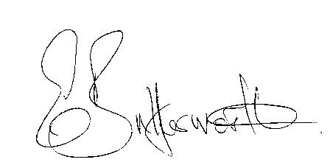Clerk

BUSINESS TO BE TRANSACTED

- Record of Members present.
- To receive apologies and approve reasons for absence.
- To receive written requests for Disclosable Pecuniary Interests where that interest is not already in the register of members’ interests.
- To approve the minutes of the meeting held on 12th April 2017.
- Public participation: To receive any questions or presentations from the public.
- County & District Councillors reports. For information only. Unless known in advance items raised for a decision will appear on the next agenda.
- Planning Matters – update on current planning applications.
- Progress reports – for information only and are items not on the agenda.
- Correspondence received:
- Temporary road closure of Salters Lane, Aston Cantlow 15th – 19th May nightly.
- Nationwide event to find Britain’s Best Village.
- Code of Conduct Review timetable.
- WRCC notification of a small amount of funding for printing of Parish Plans.
- Parish Plan status.
- Annual Accounts for Aston Cantlow Parish Council 2016/17.
- Parish Council events.
- Millenium plaque progress report.
- Lengthsman Scheme progress report.
- Defibrillator – progress report.
- Website - progress report.
- Payment of outstanding invoices.
- Councillors’ reports and items for the agenda for the next meeting. Cllrs. are reminded that this is not an opportunity for decision making.
- Date of next meeting: 8th June 2017.

