Parish of Aston Cantlow

NOTICE OF MEETING OF

PARISH COUNCIL

NOTICE IS HEREBY GIVEN THAT

A Meeting of the Parish Council for the above named Parish will be held in the Village Hall, Aston Cantlow on the 12th April 2018 following the Annual Parish Meeting.

Dated this 6th day of April 2018
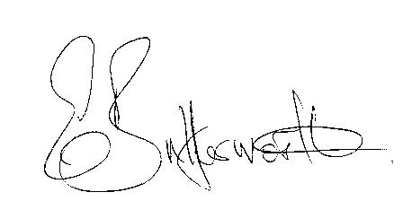Clerk

BUSINESS TO BE TRANSACTED

- Record of Members present.
- To receive apologies and approve reasons for absence.
- To receive written requests for Disclosable Pecuniary Interests where that interest is not already in the register of members’ interests.
- To approve the minutes of the parish council meeting held on 8th March 2018.
- Public participation: To receive any questions or presentations from the public.
- County & District Councillors reports. For information only. Unless known in advance items raised for a decision will appear on the next agenda.
- Planning Matters – update on current planning matters.
Consideration of the following planning applications:
18/00257/LBC The Old Green Wilmcote Lane, Aston Cantlow: Replacement of existing tiles on roof with new reclaimed tiles, install roofing felt, and repair timber roof structure as necessary.
18/00603/FUL Badbury Hill Barn, Burford Lane, Shelfield Green: Erection of dwelling, garage and creation of vehicular access for an equestrian worker (Resubmission of 17/02467/FUL).
17/03599/FUL 1 Sunnyside, Aston Cantlow: Erection of new dwelling to the side of No. 1 Sunnyside.
18/00800/COUQ Notification of prior approval for the change of use of an agricultural building into 1no.dwelling within class C3 (measuring 81sq.m).
- Progress reports – for information only and are items not on the agenda.
- Correspondence received:
- Stratford District Member Training Planning Workshop 10th May 2018 – Heritage Assets.
- Aston Cantlow Children’s Playground: continued discussions.
- New Data Protection Laws guidance and requirements: information update from Cllr. Wallis.
- Website progress on upgrade.
- Parish Council events 2018.
- Payment of outstanding invoices.
- Councillors’ reports and items for the agenda for the next meeting. Cllrs. are reminded that this is not an opportunity for decision making.
- Date of next meeting: 10th May 2018. Annual General meeting followed by ordinary Parish Council meeting.

