Parish of Aston Cantlow

NOTICE OF MEETING OF

PARISH COUNCIL

NOTICE IS HEREBY GIVEN THAT

A Meeting of the Parish Council for the above named Parish will be held in The Guild Hall, Aston Cantlow on the 12th May 2016 following the Annual General Parish Meeting

Dated this 5th day of May 2016
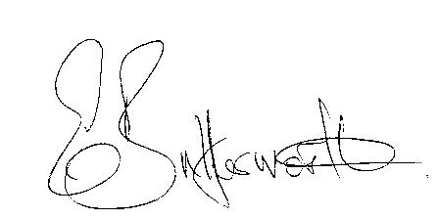Clerk

BUSINESS TO BE TRANSACTED

- Record of Members present.
- To receive apologies and approve reasons for absence.
- To receive written requests for Disclosable Pecuniary Interests where that interest is not already in the register of members’ interests.
- To approve the minutes of the annual Parish Meeting and ordinary meeting held on 14th April 2016.
- Public participation: To receive any questions or presentations from the public.
- County & District Councillors reports. For information only. Unless known in advance items raised for a decision will appear on the next agenda.
- Planning Matters – update on current planning applications.
Consideration of Planning Application No. 16/01070/FUL 18 Chapel Lane, Aston Cantlow: Single storey rear lean to wrap around extension.
- Progress reports – for information only and are items not on the agenda.
- Correspondence received:
- Flood Defence Assistance Grants information and application form.
- Living in Warwickshire survey.
- Invitation to Alcester Mayor Making - 3rd May 2016.
- Invitation to open forum meeting 26th April – Extension to Arden Forest Technology Park.
- Insurance Renewal – three quotations received.
- Annual Accounts of Aston Cantlow Parish Council 2015/16.
- Dog bin – Request received for a dog bin to be sited at AL 98 Little Alne.
- Number of Councillors.
- Standing Orders. Final draft for adoption.
- Parish Plan Update – Progress report.
- Payment of outstanding invoices.
- Councillors’ reports and items for the agenda for the next meeting. Cllrs. are reminded that this is not an opportunity for decision making.
- Date of next meeting: 9th June 2016.

