Parish of Aston Cantlow

NOTICE OF MEETING OF

PARISH COUNCIL

NOTICE IS HEREBY GIVEN THAT

A Meeting of the Parish Council for the above named Parish will be held in the Village Hall, Aston Cantlow on the 12th October 2017 at 7.30 p.m.

Dated this 5th day of October 2017
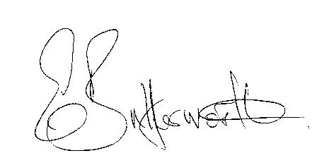Clerk

BUSINESS TO BE TRANSACTED

- Record of Members present.
- To receive apologies and approve reasons for absence.
- To receive written requests for Disclosable Pecuniary Interests where that interest is not already in the register of members’ interests.
- To approve the minutes of the parish council meeting held on 14th September 2017.
- Public participation: To receive any questions or presentations from the public.
- County & District Councillors reports. For information only. Unless known in advance items raised for a decision will appear on the next agenda.
- Planning Matters – update on current planning applications.
- Progress reports – for information only and are items not on the agenda.
- Correspondence received:
- Temporary closure of Wilmcote Lane, 25th to 27th October.
- Parish Plan status.
- Reports from Member Training Sessions: Cllr. Harvey – Community Safety Workshop & Cllr. Berry – Using Social Media for Community Engagement.
- E5341 update.
- Draft Communications & Community Engagement Strategy status, including Social media.
- Lengthsman Scheme - progress report.
- Defibrillator – progress report.
- Website - progress report.
- Payment of outstanding invoices.
- Councillors’ reports and items for the agenda for the next meeting. Cllrs. are reminded that this is not an opportunity for decision making.
- Date of next meeting: 9th November 2017.

