Parish of Aston Cantlow

NOTICE OF MEETING OF

PARISH COUNCIL

NOTICE IS HEREBY GIVEN THAT

A Meeting of the Parish Council for the above named Parish will be held in The Guild Hall, Aston Cantlow on the 12th November 2015 at 7.30 p.m.

Dated this 5th day of November 2015
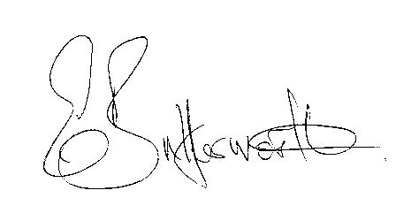Clerk

BUSINESS TO BE TRANSACTED

- Record of Members present.
- To receive apologies and approve reasons for absence.
- To receive written requests for Disclosable Pecuniary Interests where that interest is not already in the register of members’ interests.
- To approve the minutes of the meetings held on 15th October 2015.
- Public participation: To receive any questions or presentations from the public.
- County & District Councillors reports. For information only. Unless known in advance items raised for a decision will appear on the next agenda.
- Planning Matters – update on current planning applications.
To consider Planning Application No. 15/03683/FUL Fairfield, Bearley Road, Aston Cantlow: Demolition of existing garage and erection of proposed two storey side extension.
- Progress reports – for information only and are items not on the agenda.
- Correspondence received:
- CSW Broadband Update – October 2015
- Report of damaged manhole cover adjacent to The Old Forge
- Parish Sand Bag offer
- Draft Precept Estimation 2016/17
- To consider and agree activities for the current financial year.
- Social Media.
- Superfast Broadband.
- Consultation: CIL Submission Charging Schedule Friday 16 October – 5pm Friday 13 November 2015
- Audit of non listed properties of historic interest.
- Parish Plan Update.
- Payment of outstanding invoices.
- Councillors’ reports and items for the agenda for the next meeting. Cllrs. are reminded that this is not an opportunity for decision making.
- Date of next meeting: 14th January 2016.

