Parish of Aston Cantlow

NOTICE OF MEETING OF

PARISH COUNCIL

NOTICE IS HEREBY GIVEN THAT

A Meeting of the Parish Council for the above named Parish will be held in The Guild Hall, Aston Cantlow on the 13th October 2016 at 7.30 p.m.

Dated this 6th day of October 2016
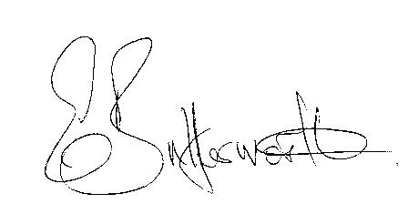Clerk

BUSINESS TO BE TRANSACTED

- Record of Members present.
- To receive apologies and approve reasons for absence.
- To receive written requests for Disclosable Pecuniary Interests where that interest is not already in the register of members’ interests.
- Co-option of Parish Councillor: an expression of interest has been received from a resident of Little Alne.
- To approve the minutes of the meeting held on 15th September 2016.
- Public participation: To receive any questions or presentations from the public.
- County & District Councillors reports. For information only. Unless known in advance items raised for a decision will appear on the next agenda.
- Planning Matters – update on current planning applications.
- Progress reports – for information only and are items not on the agenda.
- Correspondence received:
- Tesco Bags of Help funding scheme relaunch
- Temporary Road Closure of Mill Lane 28th October – 3rd November
- A resident’s report about public footpath defects – AL173.
- CSW Broadband Update - October 2016.
- Community Buildings Capital Grant Fund.
- Warwickshire Quality of Life Report.
- Parish Plan progress.
- Business Internet Banking.
- Lengthsman Scheme progress report.
- Defibrillator update.
- Parish Council Activities update
- Clerk’s appraisal.
- Asset Register.
- Payment of outstanding invoices.
- Councillors’ reports and items for the agenda for the next meeting. Cllrs. are reminded that this is not an opportunity for decision making.
- Date of next meeting: 10th November 2016.

