Parish of Aston Cantlow

NOTICE OF MEETING OF

PARISH COUNCIL

NOTICE IS HEREBY GIVEN THAT

A Meeting of the Parish Council for the above named Parish will be held in The Guild Hall, Aston Cantlow on the 14th January 2016 at 7.30 p.m.

Dated this 8th day of January 2016
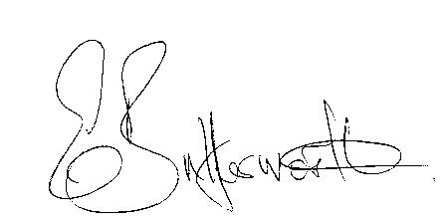Clerk

BUSINESS TO BE TRANSACTED

- Record of Members present.
- To receive apologies and approve reasons for absence.
- To receive written requests for Disclosable Pecuniary Interests where that interest is not already in the register of members’ interests.
- To approve the minutes of the meeting held on 12th November 2016.
- Public participation: To receive any questions or presentations from the public.
- County & District Councillors reports. For information only. Unless known in advance items raised for a decision will appear on the next agenda.
- Planning Matters – update on current planning applications.
- Progress reports – for information only and are items not on the agenda.
- Correspondence received:
- CSW Broadband Update – December 2015
- Citizens Advice Bureau – donation request.
- Keep Britain Tidy event - Clean for the Queen 4th - 6th March 2016.
- Interactive Community Rights usage map.
- Temporary Road Closure - A3400 Stratford Road & A4189.
- Revised Model Financial Regulations 21.11.2015.
- M. & D. Hodgson request for a Parish Plan questionnaire.
- Notification under general permitted development. Intention to install 1 x DSLAM
equipment cabinet.
- Precept 2016/17.
- Consultation: Police Precept – deadline 18th January 2016.
- Invitation for Aston Cantlow Parish Council | Working together to manage and respond to flooding. The forum will allow delegates to assess the latest government policies and funding announcements for ensuring the UK is well equipped to deal with flooding.
- To agree Parish Council activities going forward.
- Parish Plan Update - Analysis of Parish Plan questionnaire
- Payment of outstanding invoices.
- Councillors’ reports and items for the agenda for the next meeting. Cllrs. are reminded that this is not an opportunity for decision making.
- Date of next meeting: 11th February 2016.

