Parish of Aston Cantlow

NOTICE OF MEETING OF

PARISH COUNCIL

NOTICE IS HEREBY GIVEN THAT

A Meeting of the Parish Council for the above named Parish will be held in The Guild Hall, Aston Cantlow on the 14th April 2016 following the Annual Parish Meeting

Dated this 7th day of April 2016
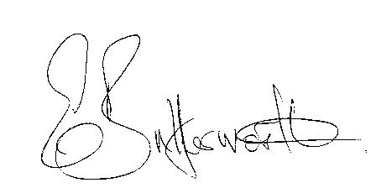Clerk

BUSINESS TO BE TRANSACTED

- Record of Members present.
- To receive apologies and approve reasons for absence.
- To receive written requests for Disclosable Pecuniary Interests where that interest is not already in the register of members’ interests.
- To approve the minutes of the meeting held on 17th March 2016.
- Public participation: To receive any questions or presentations from the public.
- County & District Councillors reports. For information only. Unless known in advance items raised for a decision will appear on the next agenda.
- Planning Matters – update on current planning applications.
- Consideration of Planning Application No. 16/00852/FUL Millbank, Mill Lane, Aston Cantlow: Construction of a three bedroom dwelling.
- Consideration of Planning Application 16/00927/FUL The Olde Barn, Shelfield: Conversion of store building and part of garage lock to two separate holiday lets (resubmission).
- Progress reports – for information only and are items not on the agenda.
- Correspondence received:
- Information from the Village Hall Chairman regarding playground expenditure.
- Updates to WALC Legal Topic notes, LTN31, LTN39 and LTN22.
- Consultation: Main modifications to Stratford on Avon District Core Strategy.
- Consultation: Proposed changes to planning process.
- Consultation: Proposals for access to Broadband in remote locations.
- Financial Regulations review.
- Standing Orders review.
- Parish Plan Update – Progress report on final draft plan.
- Payment of outstanding invoices.
- Councillors’ reports and items for the agenda for the next meeting. Cllrs. are reminded that this is not an opportunity for decision making.
- Date of next meeting: 12th May 2016. Annual General meeting followed by ordinary meeting.

