Parish of Aston Cantlow

NOTICE OF MEETING OF

PARISH COUNCIL

NOTICE IS HEREBY GIVEN THAT

A Meeting of the Parish Council for the above named Parish will be held in the Guild Hall, Aston Cantlow on the 14th June 2018 at 7.30 p.m.

Dated this 6th day of June 2018
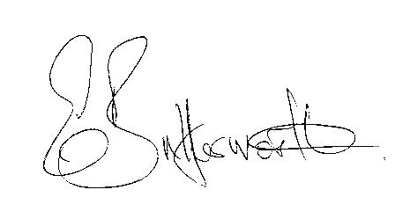Clerk

BUSINESS TO BE TRANSACTED

- Record of Members present.
- To receive apologies and approve reasons for absence.
- To receive written requests for Disclosable Pecuniary Interests where that interest is not already in the register of members’ interests.
- To approve the minutes of the AGM and ordinary parish council meeting held on 10th May 2018.
- Public participation: To receive any questions or presentations from the public.
- County & District Councillors reports. For information only. Unless known in advance items raised for a decision will appear on the next agenda.
- Planning Matters – update on current planning matters.
- Progress reports – for information only and are items not on the agenda.
- Correspondence received:
- Acknowledgement of receipt of grant from Village Hall Trustees.
- Definitive Map and Statement for Warwickshire.
- Model Standing Orders revised 2018.
- Notification of launch of Councillors’ grant fund.
- New Data Protection Laws guidance and requirements.
- Authorisation for the Proper Office to grant dispensations when required.
- Website upgrade progress report
- Parish Council events 2018 – progress to date.
- Councillors’ reports and items for the agenda for the next meeting. Cllrs. are reminded that this is not an opportunity for decision making.
- Date of next meeting: 12th July 2018.

