Parish of Aston Cantlow

NOTICE OF MEETING OF

PARISH COUNCIL

NOTICE IS HEREBY GIVEN THAT

A Meeting of the Parish Council for the above named Parish will be held in the Village Hall, Aston Cantlow on the 14th September 2017 at 7.30 p.m.

Dated this 7th day of September 2017
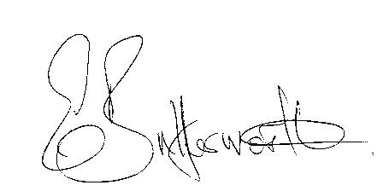Clerk

BUSINESS TO BE TRANSACTED

- Record of Members present.
- To receive apologies and approve reasons for absence.
- To receive written requests for Disclosable Pecuniary Interests where that interest is not already in the register of members’ interests.
- To approve the minutes of the parish council meeting held on 13th July 2017.
- Public participation: To receive any questions or presentations from the public.
- County & District Councillors reports. For information only. Unless known in advance items raised for a decision will appear on the next agenda.
- Planning Matters – update on current planning applications.
Consideration of Planning application No. 17/02467/FUL Badbury Hill Barn, Shelfield: Erection of dwelling for equestrian worker (Racing Yard owner) along with the erection of a garage and creation of vehicular access.
- Progress reports – for information only and are items not on the agenda.
- Correspondence received:
- Invitation from the Chairman and Consort of WCC to Open Evening & Reception on 16th September 2017.
- Member Training – Community Safety Workshop 21st September 2017.
- Cllr. Rickhards issued information about Members Delegated Budget 2017/18.
- Parish Plan status.
- E5341 update following meeting with WCC Solicitor and Rights of Way Officer.
- Draft Communications & Community Engagement Strategy status, including Social media.
- Lengthsman Scheme - progress report.
- Defibrillator – progress report.
- Website - progress report.
- Payment of outstanding invoices and re-visit BACS payment limit.
- Councillors’ reports and items for the agenda for the next meeting. Cllrs. are reminded that this is not an opportunity for decision making.
- Date of next meeting: 12th October 2017.

