Parish of Aston Cantlow

NOTICE OF MEETING OF

PARISH COUNCIL

NOTICE IS HEREBY GIVEN THAT

A Meeting of the Parish Council for the above named Parish will be held in The Guild Hall, Aston Cantlow on the 15th January 2015 at 7.30 p.m.

Dated this 8th day of January 2015
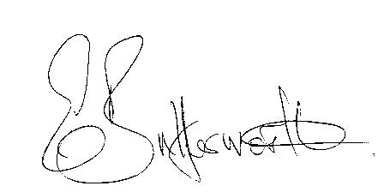Clerk

BUSINESS TO BE TRANSACTED

- Record of Members present.
- To receive apologies and approve reasons for absence.
- To receive written requests for Disclosable Pecuniary Interests where that interest is not already in the register of members’ interests.
- To approve the minutes of the meeting held on 20th November 2014.
- Public participation: To receive any questions or presentations from the public.
- District & County Councillor reports. For information only. Unless known in advance items raised for a decision will appear on the next agenda.
- Planning Matters – update on current planning applications.
To agree time scale for Cllrs. responses to Clerk when application notifications do not correspond with meetings.
- Progress reports – for information only and are items not on the agenda.
- Correspondence received:
- Additional CSW Broadband Coverage.
- CSW Broadband update – January 2015.
- Cllr. Horner Broadband update.
- Local Government pay consultation. Confirmation of agreement reached on 2014-2015 National Salary Awards.
- E5341- an enquiry from a resident as to whether the Parish Council is intending to request a closure during the winter months.
- Precept for 2015-2016.
- Payment of outstanding invoices.
- Councillors’ reports and items for the agenda for the next meeting.
- Date of next meeting: 12th February 2015.

