Parish of Aston Cantlow

NOTICE OF MEETING OF

PARISH COUNCIL

NOTICE IS HEREBY GIVEN THAT

A Meeting of the Parish Council for the above named Parish will be held in The Guild Hall, Aston Cantlow on the 15th September 2016 at 7.30 p.m.

Dated this 8th day of September 2016
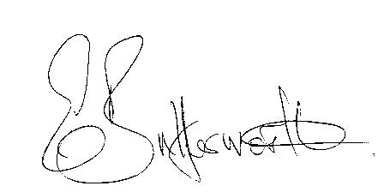Clerk

BUSINESS TO BE TRANSACTED

- Record of Members present.
- To receive apologies and approve reasons for absence.
- To receive written requests for Disclosable Pecuniary Interests where that interest is not already in the register of members’ interests.
- To approve the minutes of the meeting held on 10th August 2016.
- Public participation: To receive any questions or presentations from the public.
- County & District Councillors reports. For information only. Unless known in advance items raised for a decision will appear on the next agenda.
- Planning Matters – update on current planning applications.
- Progress reports – for information only and are items not on the agenda.
- Correspondence received:
- Land at Gaydon/Lighthorne Heath SPD - Adoption Statement.
- WCC Flood Risk Management Newsletter.
- Alcester/Bidford Community Forum - Tuesday 20th September.
- A resident’s concerns about speeding traffic through Little Alne.
- Parish Plan – to ratify adoption of the final plan.
- Lengthsman Scheme progress report.
- Defibrillator and Parish Council Activities updates.
- Big Lottery Fund Grant
- Flying a Flag for commonwealth Day 2017.
- Payment of outstanding invoices.
- Councillors’ reports and items for the agenda for the next meeting. Cllrs. are reminded that this is not an opportunity for decision making.
- Date of next meeting: 13th October 2016.

