Parish of Aston Cantlow

NOTICE OF MEETING OF

PARISH COUNCIL

NOTICE IS HEREBY GIVEN THAT

A Meeting of the Parish Council for the above named Parish will be held in The Guild Hall, Aston Cantlow on the 15th October 2015 at 7.30 p.m.
(This meeting has been re-scheduled from the 8th October)

Dated this 5th day of October 2015
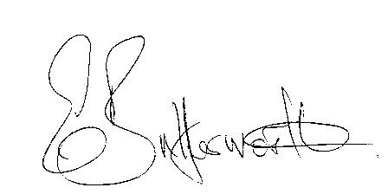Clerk

BUSINESS TO BE TRANSACTED

- Record of Members present.
- To receive apologies and approve reasons for absence.
- To receive written requests for Disclosable Pecuniary Interests where that interest is not already in the register of members’ interests.
- To approve the minutes of the meetings held on 10th September 2015.
- Public participation: To receive any questions or presentations from the public.
- County & District Councillors reports. For information only. Unless known in advance items raised for a decision will appear on the next agenda.
- Planning Matters – update on current planning applications.
- Progress reports – for information only and are items not on the agenda.
- Correspondence received:
- Temporary closure of CD39 Burford Lane, Shelfield
- Invitation to WALC A.G.M. 4th November 2015
- Complaint regarding the condition of public footpaths and stiles in the Parish.
- Request from resident to report blocked drains on the B4089, Little Alne.
- To consider S137 grants to Tennis Club & PCC, plus consideration of donations.
- To consider and agree activities for the current financial year.
- Parish Council Representative for Village Hall.
- Consultation: Implementation Options consultation 18th September – 30th October 2015
- Parish Plan update.
- Bank Mandate to be updated due to incorrect forms being supplied by the Bank.
- Payment of outstanding invoices.
- Councillors’ reports and items for the agenda for the next meeting. Cllrs. are reminded that this is not an opportunity for decision making.
- Date of next meeting: 12th November 2015.

