Parish of Aston Cantlow

NOTICE OF MEETING OF

PARISH COUNCIL

NOTICE IS HEREBY GIVEN THAT

A Meeting of the Parish Council for the above named Parish will be held in The Guild Hall, Aston Cantlow on the 17th March 2016 at 7.30 p.m.

Dated this 11th day of March 2016
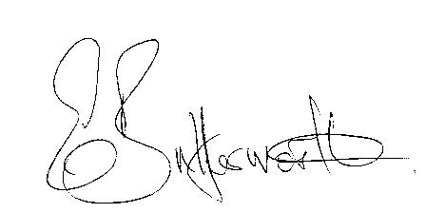Clerk

BUSINESS TO BE TRANSACTED

- Record of Members present.
- To receive apologies and approve reasons for absence.
- To receive written requests for Disclosable Pecuniary Interests where that interest is not already in the register of members’ interests.
- Ali Mainey, Community Development Worker, WCC, to provide support for the Lengthsman Scheme.
- To approve the minutes of the meeting held on 11th February 2016.
- Public participation: To receive any questions or presentations from the public.
- County & District Councillors reports. For information only. Unless known in advance items raised for a decision will appear on the next agenda.
- Complaints regarding vehicles parked adjacent to the phone box in Bearley Road.
- Planning Matters – update on current planning applications.
- Consideration of Planning Application No. 16/00654/FUL Fairfield Bearley Road, Aston Cantlow: Proposed demolition of existing garage and erection of two storey side extension.
- Planning Committee notification: 15/04226/FUL Pools Barn Farm, Little Alne
- Progress reports – for information only and are items not on the agenda.
- Correspondence received:
- WALC Financial Briefing F01E-16 update to model financial regulations.
- New Audit scale of fees.
- Stratford on Avon Core Strategy examination update – March 2016.
- Pre-submission consultation: Wilmcote & Pathlow Neighbourhood Plan.
- To consider request for donation to Shakespeare Hospice.
- Financial Regulations review.
- Standing Orders review.
- Aston Cantlow – Post PLP Flood Group.
- To agree Parish Council activities going forward.
- Parish Plan Update - Analysis of Parish Plan questionnaire.
- Payment of outstanding invoices.
- Councillors’ reports and items for the agenda for the next meeting. Cllrs. are reminded that this is not an opportunity for decision making.
- Date of next meeting: 14th April 2016. Annual Parish meeting followed by ordinary meeting.

