Parish of Aston Cantlow

NOTICE OF MEETING OF

PARISH COUNCIL

NOTICE IS HEREBY GIVEN THAT

A Meeting of the Parish Council for the above named Parish will be held in The Guild Hall, Aston Cantlow on the 23rd April 2015 at 7.30 p.m.

Dated this 17th day of April 2015
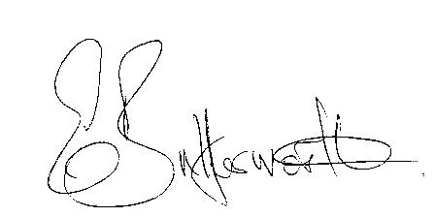Clerk

BUSINESS TO BE TRANSACTED

- Record of Members present.
- To receive apologies and approve reasons for absence.
- To receive written requests for Disclosable Pecuniary Interests where that interest is not already in the register of members’ interests.
- To approve the minutes of the meetings held on 15th January, 19th March and Annual Parish meeting 9th April 2015.
- Public participation: To receive any questions or presentations from the public.
- County Councillor report. For information only. Unless known in advance items raised for a decision will appear on the next agenda.
- Planning Matters – update on current planning applications.
- Progress reports – for information only and are items not on the agenda.
- Correspondence received:
- WRCC: Affordable Rural Housing: A practical guide for Parish Councils.
- CSW Broadband Update - Voucher Scheme Launch March 2015.
- County Councillor: Delegated Road Safety Budget.
- Insurance renewal documents.
- Notice of Uncontested Elections.
- To consider S137 grants – carried forward from February meeting.
- Parish Plan update.
- Review of Asset Register.
- Playground: Complaints to Village Hall Committee regarding unacceptable behaviour of children from the village in and around that area.
- Payment of outstanding invoices.
- Councillors’ reports and items for the agenda for the next meeting. Each Cllr. is requested to use this opportunity to report on minor matters for information not included elsewhere on the agenda and to raise items for future agendas. Cllrs. are reminded that this is not an opportunity for decision making.
- Date of next meeting: To be arranged.

