Parish of Aston Cantlow

NOTICE OF MEETING OF

PARISH COUNCIL

NOTICE IS HEREBY GIVEN THAT

A Meeting of the Parish Council for the above named Parish will be held in The Guild Hall, Aston Cantlow on the 25th June 2015 at 7.30 p.m.

Dated this 17th day of June 2015
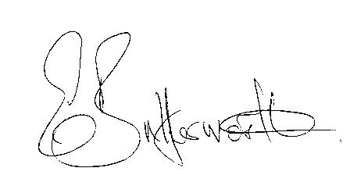Clerk

BUSINESS TO BE TRANSACTED

- Record of Members present.
- To receive apologies and approve reasons for absence.
- To receive written requests for Disclosable Pecuniary Interests where that interest is not already in the register of members’ interests.
- To approve the minutes of the meetings held on 15th January, 19th March and Annual Parish meeting 9th April 2015.
- Public participation: To receive any questions or presentations from the public.
- County & District Councillors reports. For information only. Unless known in advance items raised for a decision will appear on the next agenda.
- Planning Matters – update on current planning applications and to consider the following Planning applications:
Application No. 15/01972/TREE 3 Guild Road, Aston Cantlow. Unknown species: fell.
Application Nos. 15/01898/FUL & 15/01899/LBC Shelfield House, Shelfield. Conversion of Cart Shed to Residential Dwelling and Renovation of Dove Cote (revisions to planning application 14/01107/FUL).
- Progress reports – for information only and are items not on the agenda.
- Annual Accounts of Aston Cantlow Parish Council for 2014/15.
- Parish Council Insurance Renewal. To ratify renewal for one year was agreed by the previous Council prior to the elections.
- Correspondence received:
-WALC – Legal Briefing Note L02-15 Transparency Code for Smaller Authorities with a turnover not exceeding £25,000
-WALC – 4th edition of the Good Councillors Guide plus addendum.
- WALC Induction training for new Councillors & Clerks.
- Notifications of elections and results.
- The Mayor of Alcester, Professor Councillor Clive Neal - Sturgess – invitation to attend his civic service on Sunday 6th September 2015
- Notice: Alcester Film Club with Afternoon Tea, Jubilee Centre, Friday 12th June.
- Information about the National Rural Crime Network.
- To consider S137 grants – carried forward from February meeting.
- To re-visit and agree Parish Council procedures for the new term.
- Parish Plan update.
- Payment of outstanding invoices.
- Councillors’ reports and items for the agenda for the next meeting. Cllrs. are reminded that this is not an opportunity for decision making.
- Date of next meeting: 10th September 2015.

