PARISH OF ASTON CANTLOW

NOTICE OF SPECIAL MEETING OF THE PARISH COUNCIL

Dear Sir/Madam

You are hereby summoned to attend a meeting of Aston Cantlow Parish Council to be held in the Guild Room, Aston Cantlow on 6th June 2018 at 7.30 p.m. for the purpose of transacting the following business. 8.30

BUSINESS TO BE TRANSACTED

- Present.

- Apologies for Absence.

- To receive written requests for Disclosable Pecuniary/Non Pecuniary Interests where that interest is not already in the register of members’ interests.

- To consider an amendment/additional information received for Planning Application No. 18/01009/FUL Pools Barn Farm, Little Alne: Addendum to Transport Statement to address concerns of the Parish Council and local residents. Tree survey with supporting drawings.

Dated this 30th day of May 2018
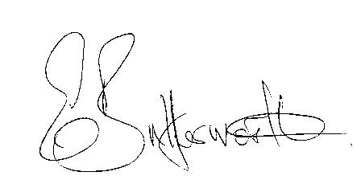Clerk

