Aston Cantlow Village Hall
Standard Conditions of Hire
From January 2013
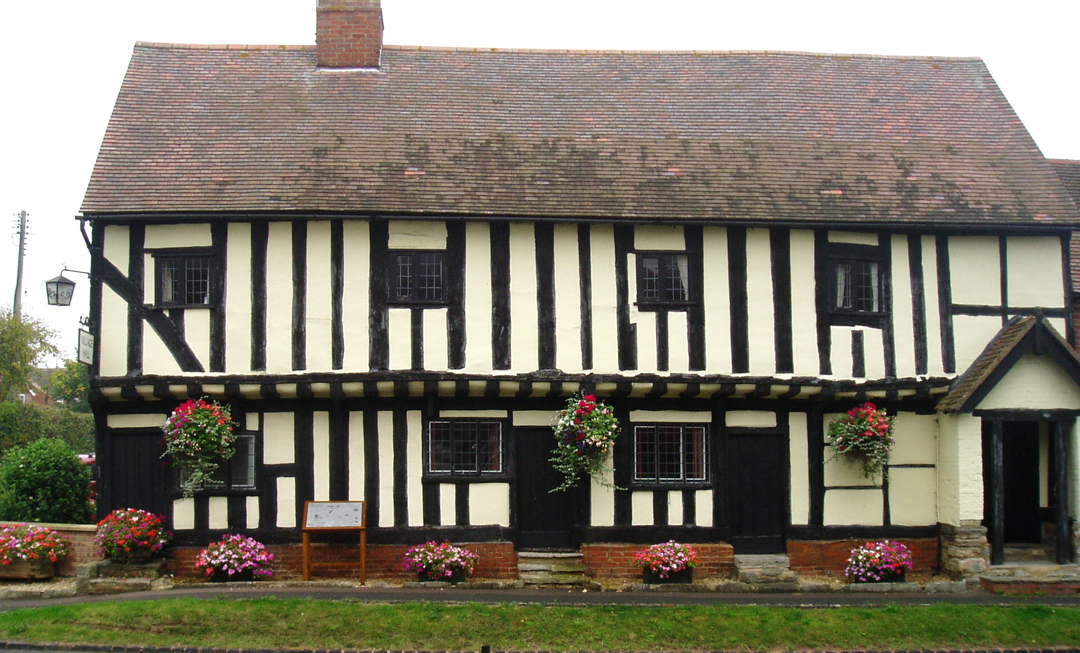
BEARLEY ROAD
ASTON CANTLOW
HENLEY-IN-ARDEN
B95 6HZ

Bookings Clerk/Caretaker
Mrs H Wickenkamp
Guild Corner Cottage
01789 488304

These standard conditions apply to all uses of the village hall. If the Hirer is in any doubt as to the meaning of the following, the Hall Secretary or Booking Clerk should be consulted prior to the hiring.
1. Supervision
The Hirer shall, during the period of the hiring, be responsible for: supervision of the premises, the fabric and the contents; their care, safety from damage however slight or change of any sort; and the behaviour of all persons using the premises whatever their capacity, including proper supervision of car parking arrangements so as to avoid obstruction of the highway. As directed by the Hall Secretary, the Hirer shall make good or pay for all damage (including accidental damage) to the premises or to the fixtures, fittings or contents and for loss of contents.

THE HALL MUST NOT BE LEFT UNLOCKED WHEN UNOCCUPIED.
The Hirer must ensure that the entrance door is MANNED during the WHOLE of the Hire Period.
The maximum number of persons permitted by Licence is 200 in the Main Hall (106 if seated at tables, 70 if seated with dancing), and 60 in the Guild Room (37 seated at tables). Tickets or invitations beyond those numbers must not be issued. The Hirer will be responsible for ensuring that these limits are not exceeded, and if necessary must regulate entry into the hall.
2. Use of Premises
The Hirer shall not use the premises for any purpose other than that described in the Hiring Agreement and shall not sub-hire or use the premises or allow the premises to be used for any unlawful purpose or in any unlawful way nor do anything or bring onto the premises anything which may endanger the same or render invalid any insurance policies in respect thereof nor allow the consumption of alcohol thereon without written permission.

3. Gaming, Betting and Lotteries
The Hirer shall ensure that nothing is done on or in relation to the premises in contravention of the law relating to gaming, betting and lotteries.

4. Licences
If an ALCOHOL LICENCE has been granted it is an offence to sell tickets at the door. It is ILLEGAL to sell alcohol without a licence, and the licence MUST be shown to the Bookings Clerk at least one week before the hire date.

The Village Hall holds a Premises Licence. If any other licence is required in respect of any activity in the Village Hall, the hirer must ensure that they hold the relevant licence.

If you plan to sell alcohol at your event, you will need to seek written permission from the management committee in order to use one of the Village Hall’s TENs (Temporary Event Notices).

Failure to do so will result in cancellation of the hiring without compensation because there is a limit on the number of TENs that can be granted annually for any premises. Lack of co-operation could affect future fundraising by the hall management committee and local voluntary organisations.
The Hirer agrees with the Village Hall to be present (or its authorised representative, if appropriate) during the hiring and to comply fully with this Hire Agreement.
It is hereby agreed that the Standard Conditions of Hire together with any Special Conditions of Hire shall form part of the terms of this Hiring Agreement unless specifically excluded by agreement in writing between the Village Hall and the Hirer.
None of the provisions of this Agreement are intended to or will operate to confer any benefit pursuant to the Contracts (Rights of Third Parties) Act 1999 on a person who is not named as a party to this Agreement.
5. Public Safety Compliance
The Hirer shall comply with all conditions and regulations made in respect of the premises by the Fire Authority, Local Authority, the Licensing Authority or otherwise, particularly in connection with any event which constitutes regulated entertainment, at which alcohol is sold or provided or which is attended by children.

- The Hirer must ensure that they have received instruction in the following matters:
- the action to be taken in event of fire. This includes calling the Fire Brigade and evacuating the hall.
- the location and use of fire equipment. (diagram of location is on the noticeboard)
- escape routes and the need to keep them clear.
- method of operation of escape door fastenings.
- appreciation of the importance of any fire doors and of closing all fire doors at the time of a fire.

- In advance of an entertainment or play the Hirer shall check the following items:
- that all escape routes are free of obstruction and can be
safely used.
- that exit signs are illuminated.
- that there are no obvious fire hazards on the premises.
- that they are aware of the Fire Assembly Point in the car park.

6. Means of Escape
(a) All means of exit from the premises must be kept free from obstruction and immediately available for instant free public exit.
(b) The emergency lighting supply illuminating all exit signs and routes must be turned on during the whole of the time the premises are occupied (if not operated by an automatic mains failure switching device).
7. Outbreaks of Fire
The Fire Brigade shall be called to any outbreak of fire, however slight, and details thereof shall be given to the secretary of the management committee.

8. Health and Hygiene
The Hirer shall, if preparing, serving or selling food, observe all relevant food health and hygiene legislation and regulations. In particular dairy products, vegetables and meat on the premises must be refrigerated and stored in compliance with the Food Temperature Regulations.

9. Rubbish
The Hirer is responsible for cleaning up any mess and rubbish in any part of the property including outside, otherwise an extra minimum charge of £20.00 will be made. There are small domestic sized bins available outside of the premises for small amounts of general waste (black bin), paper, bottles and tins (blue top bin) or organic waste (green bins). Any substantial amounts of rubbish or organic waste generated by the hirer or their caterers should be taken home with them at the end of the event or the £20 extra charge will be incurred.
10 Electrical Appliance Safety
The Hirer shall ensure that all electrical appliances brought by them to the premises and used there shall be PAT Tested, safe, in good working order, and used in a safe manner in accordance with the Electricity at Work Regulations 1989. Where a residual circuit breaker is provided the hirer must make use of it in the interests of public safety.

11. Indemnity
- The Hirer shall indemnify and keep indemnified each member of the Village Hall management committee and the Village Hall’s employees, volunteers, agents and invitees against (a) the cost of repair of any damage done to any part of the premises including the curtilage thereof or the contents of the premises (b) all claims, losses, damages and costs in respect of damage or loss of property or injury to persons arising as a result of the use of the premises (including the storage of equipment) by the Hirer, and (c) all claims, losses, damages and costs suffered or incurred as a result of any nuisance caused to a third party as a result of the use of the premises by the Hirer.

- The Hirer should consider taking out adequate insurance to insure the Hirer and members of the Hirer’s organisation and invitees against the Hirer’s liability under paragraph 10(a) and all claims arising as a result of the hire and on demand shall produce the policy and current receipt or other evidence of cover to the Hall Secretary.

The Village Hall is insured against any claims arising out of its own negligence.

12 . Accidents and Dangerous Occurrences
The Hirer must report all accidents involving injury to the public to a member of the Village Hall management committee as soon as possible and complete the relevant section in the Village Hall’s accident book. The Accident Book is kept in the kitchen.
Any failure of equipment belonging to the Village Hall or brought in by the Hirer must also be reported as soon as possible.
Certain types of accident or injury must be reported on a special form to the local authority in accordance with the Reporting of Injuries, Diseases and Dangerous Occurrences Regulations 1995 (RIDDOR).
A First Aid box can be found in the Hallway and in the Kitchen.
13. Explosives and Flammable Substances
The hirer shall ensure that:
(a) Highly flammable and explosive substances are not brought into, or used in any part of the premises and/or property.

- No internal decorations of a combustible nature (e.g. polystyrene, cotton wool) shall be erected without the consent of the management committee. No decorations are to be put up near light fittings or heaters.

14. Heating
The Hirer shall ensure that no unauthorised heating appliances shall be used on the premises when open to the public without the consent of the management committee. Portable Liquefied Propane Gas (LPG) heating appliances shall not be used.

15. Drunk and Disorderly Behaviour and Supply of Illegal Drugs
The Hirer shall ensure that in order to avoid disturbing neighbours to the hall and avoid violent or criminal behaviour, care shall be taken to avoid excessive consumption of alcohol. Drunk and disorderly behaviour shall not be permitted either on the premises or in its immediate vicinity. Alcohol shall not be served to any person suspected of being drunk nor to any person suspected of being under the age of 18. Any person suspected of being drunk, under the influence of drugs or who is behaving in a violent or disorderly way shall be asked to leave the premises. No illegal drugs may be brought onto the premises.

16. Animals
The Hirer shall ensure that no animals (including birds) except guide dogs are brought into the premises, other than for a special event agreed to by the Village Hall. No animals whatsoever are to enter the kitchen at any time.

17. Compliance with The Children Act 1989
The Hirer shall ensure that any activities for children under eight years of age comply with the provisions of The Children Act of 1989 and that only fit and proper persons who have passed the appropriate Criminal Records Bureau checks have access to the children (checks may also apply where children over eight and vulnerable adults are taking part in activities). The Hirer shall provide the Village Hall committee with a copy of their Child Protection Policy on request.

18. Fly Posting
The Hirer shall not carry out or permit fly posting or any other form of unauthorised advertisements for any event taking place at the premises, and shall indemnify and keep indemnified each member of the Village Hall’s management committee accordingly against all actions, claims and proceedings arising from any breach of this condition. Failure to observe this condition may lead to prosecution by the local authority.

19. Sale of Goods
The Hirer shall, if selling goods on the premises, comply with Fair Trading Laws and any code of practice used in connection with such sales. In particular, the Hirer shall ensure that the total prices of all goods and services are prominently displayed, as shall be the organiser’s name and address and that any discounts offered are based only on Manufacturers’ Recommended Retail Prices.
20. Cancellation
If the Hirer wishes to cancel the booking before the date of the event and the Village Hall is unable to conclude a replacement booking, the question of the payment or the repayment of the fee shall be at the discretion of the Village Hall. The Village Hall reserves the right to cancel this hiring by written notice to the Hirer in the event of:
- the premises being required for use as a Polling Station for a Parliamentary or Local Government election or by-election

- the Village Hall management committee reasonably considering that (i) such hiring will lead to a breach of licensing conditions, if applicable, or other legal or statutory requirements, or (ii) unlawful or unsuitable activities will take place at the premises as a result of this hiring
- the premises becoming unfit for the use intended by the Hirer

(d) an emergency requiring use of the premises as a shelter for the victims of flooding, snowstorm, fire, explosion or those at risk of these or similar disasters.
In any such case the Hirer shall be entitled to a refund of any deposit already paid, but the Village Hall shall not be liable to the Hirer for any resulting direct or indirect loss or damages whatsoever.

21. End of Hire
The Hirer shall be responsible for leaving the premises and surrounding area in a clean and tidy condition, floors swept and rubbish cleared away, heating and lighting, cooking equipment, taps etc. switched off, doors and windows properly locked and secured (unless indicated or directed otherwise) and any contents temporarily removed from their usual positions properly replaced. The Village Hall shall be at liberty to make an additional charge of at least £20.00 where the Hall is not left in a clean condition. See point 9 about clearing away rubbish.

22. Noise
The Hirer shall ensure that the minimum of noise is made on arrival and departure, particularly late at night and early in the morning. Noise must be reduced after 11pm to a level which will not disturb nearby residents.
SPECIAL CONDITIONS RELATING TO ALL EVENTS WITH MUSIC
We have installed a Noise Level Monitor, and ALL ELECTRICALLY POWERED MUSIC PLAYING EQUIPMENT, AMPLIFIERS, DISCO OR KARAOKI equipment must be powered through this Monitor. Any resultant sound level, which exceeds the decibel level laid down by the Stratford-upon-Avon District Council, will automatically cause the power to be cut off until the sound level falls to the acceptable level. The correct plug socket is clearly marked, and is for the SOLE USE OF ALL MUSIC EQUIPMENT.
It is the Hirer’s responsibility to see that this socket is in use at all times when any music equipment is being used. Any failure to comply with this condition which results in the issuing of a Summons will result in any penalties and costs being passed on to the Hirer. The Hirer who allows music playing equipment to be used MUST SIGN the appropriate portion of the Booking Form at the time the reservation is made.
24. Stored Equipment
The Village Hall accepts no responsibility for any stored equipment or other property brought on to or left at the premises, and all liability for loss or damage is hereby excluded. All equipment and other property (other than stored equipment) must be removed at the end of each hiring or fees will be charged for each day or part of a day at the hire fee per hiring until the same is removed.
The Village Hall may, in its discretion in any of the following circumstances, dispose of any such items by sale or otherwise on such terms and conditions as it thinks fit, and charge the Hirer any costs incurred in storing and selling or otherwise disposing of the same.
Namely:
- in respect of stored equipment, failure by the Hirer either to pay any storage charges due and payable or to remove the same within 7 days after the agreed storage period has ended
(b) in respect of any other property brought on to the premises for the purposes of the hiring, failure by the Hirer to remove the same within 7 days after the hiring
24. No Alterations
No alterations or additions may be made to the premises nor may any fixtures be installed or placards, decorations or other articles be attached in any way to any part of the premises without the prior written approval of the Hall Secretary. Any alteration, fixture or fitting or attachment so approved shall at the discretion of the Village Hall remain in the premises at the end of the hiring. It will become the property of the Village Hall unless removed by the hirer who must make good to the satisfaction of the hall or, if any damage caused to the premises by such removal. If decorations are required these must be attached to the PERMANENT FIXINGS in the Hall. Sellotape, BluTack or similar materials MUST NOT BE USED. All decorations MUST BE REMOVED after the event.

25. No Rights
The Hiring Agreement constitutes permission only to use the premises and confers no tenancy or other right of occupation on the Hirer.

26. Telephone
There is no telephone in Aston Cantlow Village Hall, the nearest public phone is on Bearley Road Aston Cantlow 100 yards away on turning right out of the Village Hall.

27. Teenage Parties
Bookings for teenage parties are only accepted from a parent or guardian. In order to avoid problems that sometimes occur with teenage parties, we strongly recommend the following safeguards:
- as organiser, make sure that you have read and fully understand all of the conditions of hire, and have done what is necessary to observe them.
- if your child has made some of the arrangements, make sure you know in advance what these are and have approved them
- arrange for a sufficient number of responsible adults to attend the party, to:
  - exercise general supervision
  - be fully prepared, should there be an emergency
  - make sure that guests behave in an acceptable way, and don't put others at risk
  - keep an eye on the emergency exits (it is not uncommon for "gatecrashers" to tap on the windows and doors to persuade friends among the other guests to let them in)
  - keep an eye on the toilets (where surreptitious gatherings have been known to take place)
  - admit guests by invitation only, keeping the main doors manned at all times so that:
  - they are not blocked as an emergency exit
  - the guests remain inside the Hall for the party, and don't cause nuisance or excessive noise by continually "coming and going"
  - undesirable "gatecrashers" don't get in to spoil the party
  - don’t allow alcoholic drinks of any kind to be bought into the hall (It's a sad fact that underage drinkers do try to smuggle them in)
  - don’t allow foiled "gatecrashers" to have their own party in the car park (It does happen)
  - at the end of the event, help guests to leave quickly and quietly
28. Bouncy Castles
If the bouncy castle is hired with a supervisor, the supplier must have their own Public Liability Insurance.
If, however, the bouncy castle is ‘hired in’ the following will apply:
    - an adult representative is to act in a supervisory capacity at all times
    - only allow children of similar age and size on the castle at any one time.
    - avoid any overcrowding and ensure that the manufacturer’s recommendations for numbers are not exceeded.
    - soft gym mats should be positioned to cover any hard surface at the open front of the castle.
    - ensure that users of the castle remove any potentially dangerous objects such as jewellery, buckles, shoes etc.
    - ensure that the castle is moored securely to the ground
    - do not allow children over the age of 12 years to use the castle.

29. Barbecues
BBQ’s are not permitted.
30. Smoking
The Hirer shall and shall ensure that the Hirer’s invitees, comply with the prohibition of smoking in public spaces provisions of the Health Act 2006 and regulations made there under. Anyone breaching this provision shall be asked, by the Hirer, to leave the Hall.
31.Deposits
A cash deposit of £100.00 is required for all parties, weddings etc to cover damages.
ACVH HIRING CONDITIONS VERSION 5 January 2013

