Parish of Aston Cantlow

NOTICE OF MEETING OF

PARISH COUNCIL

NOTICE IS HEREBY GIVEN THAT

A Meeting of the Parish Council for the above named Parish will be held in the Guild Hall, Aston Cantlow on the 6th September 2018 at 8.15 p.m.

Please note this is replacing the original scheduled meeting for the 13th September.

Dated this 30th day of August 2018
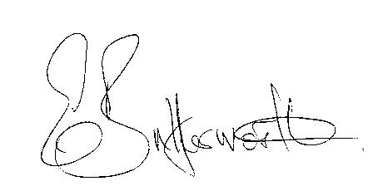Clerk

BUSINESS TO BE TRANSACTED

- Record of Members present.
- To receive apologies and approve reasons for absence.
- To receive written requests for Disclosable Pecuniary Interests or Non-Pecuniary interests where that interest is not already in the register of members’ interests.
- To approve the minutes of the parish council meeting held on 9th August 2018.
- Public participation: To receive any questions or presentations from the public.
- County & District Councillors reports. For information only. Unless known in advance items raised for a decision will appear on the next agenda.
- Planning Matters – update on current planning matters.
Consideration of the following Planning Applications:
18/01366/LBC & 18/01365/FUL Holyoake Farm/Barn – amendment applications.
18/02157/FUL 1 Sunnyside, Aston Cantlow – 2 storey side extension and single storey rear extension.
18/02302/FUL Land adjacent to 1 Sunnyside, Aston Cantlow - Erection of new dwelling to the side (West) of 1 Sunnyside.
18/01821/FUL Ardencote Farm, Shelfield Green – Erection of indoor horse training arena.
- Progress reports – for information only and are items not on the agenda.
- Correspondence received:
- Advisory of Electric Blanket Testing Campaign 1st – 5th October 2018.
- Traffic speeds through Little Alne.
- Councillors’ reports and items for the agenda for the next meeting. Cllrs. are reminded that this is not an opportunity for decision making.
- Date of next meeting: 11th October 2018.

