Parish of Aston Cantlow

NOTICE OF MEETING OF

PARISH COUNCIL

NOTICE IS HEREBY GIVEN THAT

A Meeting of the Parish Council for the above named Parish will be held on the 8th July 2020 at 7.00 p.m.

For the health and well-being of our community as a result of the Covid-19 crisis and following the instruction of the Prime Minister’s address on 23rd March 2020, all Parish Council meetings will be held remotely until further notice using Zoom software.

Should any resident wish to submit a question to the Parish Council or to participate in the meeting via Zoom, please email the Clerk lizbutterworth1@btinternet.com by 2 pm on Monday 6th July.

Dated this 2nd day of July 2020
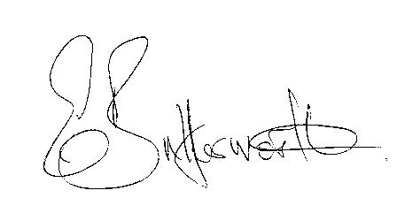Clerk

BUSINESS TO BE TRANSACTED

- Record of Members present.
- To receive apologies and approve reasons for absence.
- To receive written requests for Disclosable Pecuniary Interests or Non-Pecuniary interests where that interest is not already in the register of members’ interests.
- To approve the minutes of the Parish Council meeting held on 13th February 2020.
- Public participation: To receive any questions or presentations from the public
- Correspondence received: All correspondence sent electronically to date will be taken as read.
- Annual Governance and Accountability Return 2019/20.
- Date of next meeting to be advised.

