Parish of Aston Cantlow

NOTICE OF MEETING OF

PARISH COUNCIL

NOTICE IS HEREBY GIVEN THAT

A Meeting of the Parish Council for the above named Parish will be held on the 8th October 2020 at 7.30 p.m.

For the health and well-being of our community as a result of the Covid-19 crisis and following the instruction of the Prime Minister’s address on 23rd March 2020, all Parish Council meetings will be held remotely until further notice using Zoom software.

Should any resident wish to submit a question to the Parish Council or to participate in the meeting via Zoom, please email the Clerk lizbutterworth1@btinternet.com by 2 pm on Tuesday 6th October 2020.

Dated this 2nd day of October 2020
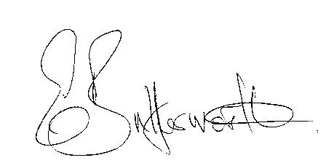Clerk

BUSINESS TO BE TRANSACTED

- Record of Members present.
- To receive apologies and approve reasons for absence.
- To receive written requests for Disclosable Pecuniary Interests or Non-Pecuniary interests where that interest is not already in the register of members’ interests.
- Minutes of the meeting held on 8th July were approved electronically and have been signed by the Chairman.
- Public participation: To receive any questions or presentations from the public.
- County & District Councillors reports.
- Planning Matters: To consider planning application No. 20/02470/FUL 18 Guild Road, Aston Cantlow: Erection of first floor side extension, a single storey rear extension and a ground floor extension to the existing garage together with internal and external alterations.
- Correspondence received: All correspondence sent electronically to date will be taken as read.
9. Date of next meeting: to be advised.

