Parish of Aston Cantlow

NOTICE OF MEETING OF

PARISH COUNCIL

NOTICE IS HEREBY GIVEN THAT

A Meeting of the Parish Council for the above named Parish will be held in the Guild Hall, Aston Cantlow on the 9th August 2018 at 7.30 p.m.

Dated this 2nd day of August 2018
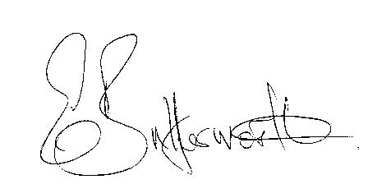Clerk

BUSINESS TO BE TRANSACTED

- Record of Members present.
- To receive apologies and approve reasons for absence.
- To receive written requests for Disclosable Pecuniary Interests or Non-Pecuniary interests where that interest is not already in the register of members’ interests.
- To approve the minutes of the parish council meeting held on 14th June 2018.
- Public participation: To receive any questions or presentations from the public.
- County & District Councillors reports. For information only. Unless known in advance items raised for a decision will appear on the next agenda.
- Planning Matters – update on current planning matters.
Consideration of Planning Application No.18/01719/FUL The Old School House, Church Lane, Aston Cantlow: Demolish late addition brick outbuilding solid fuel store and install PPG tank with associated works.
- Progress reports – for information only and are items not on the agenda.
- Correspondence received:
- Advance notification of the Alcester Seco 10k run on Sunday 7th October 2018.
- Closure of C39 Whitehouse Hill, Aston Cantlow 13th – 24th August to facilitate drainage works and remedial works to gabions.
- Councillor Briefings – Planning Consultation 9th or 23rd August.
- Family Fund Day flyer - 50th anniversary of the playground celebrations.
- Confirmation of Definitive Map Modification Order AL86.
- Notification of adoption of the Canal Quarter SPD.
- Aston Cantlow Playground – to consider proposal and quotation for fitness equipment.
- Traffic speeds through Little Alne
- Councillors’ reports and items for the agenda for the next meeting. Cllrs. are reminded that this is not an opportunity for decision making.
- Date of next meeting: 13th September 2018.

