Parish of Aston Cantlow

NOTICE OF MEETING OF

PARISH COUNCIL

NOTICE IS HEREBY GIVEN THAT

A Meeting of the Parish Council for the above named Parish will be held in the Guild Hall, Aston Cantlow on the 10th January 2019 at 7.30 p.m.

Dated this 3rd day of January 2019
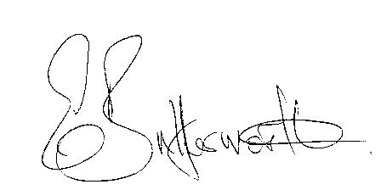Clerk

BUSINESS TO BE TRANSACTED

- Record of Members present.
- To receive apologies and approve reasons for absence.
- To receive written requests for Disclosable Pecuniary Interests or Non-Pecuniary interests where that interest is not already in the register of members’ interests.
- To approve the minutes of the parish council meeting held on 15 November 2018.
- Public participation: To receive any questions or presentations from the public.
- County & District Councillors reports. For information only. Unless known in advance items raised for a decision will appear on the next agenda.
- Planning Matters – update on current planning matters.
- Progress reports – for information only and are items not on the agenda
- Correspondence received:
- Information sheet regarding grievances against Parish & Town Councillors.
- Police Precept consultation.
- Notification that SDC is committed to assisting the provision of improved fast broadband
connectivity for our communities.
- Temporary closure of D5339, Shelfield Green Lane its junction with Burford Lane 10th to
16th January 2019 for drainage work.
- Temporary road closure Mill Lane 13th to 27th December – sewerage leak.
- Reassurance provided that local policing will be unaffected by alliance changes.
- Christmas information received from Information Commissioners Office.
- Notification of new pay scales for Clerks and other employees due to the introduction of the National living wage.
10. Final Precept request 2019/2020.
11. Traffic speeds through Little Alne.
12. Aston Cantlow Playground update.
12. Councillors’ reports and items for the agenda for the next meeting. Cllrs. are reminded that this is not an opportunity for decision making.
13. Date of next meeting: 14th February 2019.

