Parish of Aston Cantlow

A meeting of the Parish Council for the above named Parish will be held on 10th March 2022 at 7.00 pm in Aston Cantlow Village Hall

Dated this 4th day of March 2022
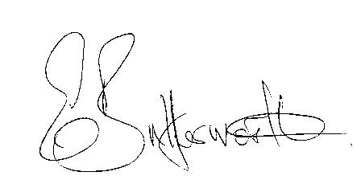Clerk

BUSINESS TO BE TRANSACTED

- Record of Members present.
- To receive apologies and approve reasons for absence.
- Declarations of interest in items on the agenda
- Public participation.
- To approve the minutes of the meeting held on 31st January 2022
- County & District Councillors’ reports.
- To consider the following planning applications:
Planning application Nos. 22/00620/TREE & 22/00619/TREE The Old School House, Aston Cantlow
Amendment Application No. 22/00343/FUL Private Parkland, Burford Lane, Shelfield
Planning Application No. 22/00282/VARY Ardencroft, Newnham
8. Request from Aston Cantlow Churchwarden’s for a grant to cover the cost of repairs for the churchyard mower.
9. Notification of WALC membership fees for 2022-23 for consideration.
10. Notification from NALC - Section 137 expenditure limit for 2022-23 is £8.82.
11. Campaign to recruit parish councillors.
12. Date of next meeting: 12th May 2022.

