Parish of Aston Cantlow

NOTICE OF MEETING OF

PARISH COUNCIL

NOTICE IS HEREBY GIVEN THAT

A Meeting of the Parish Council for the above named Parish will be held in the Guild Hall, Aston Cantlow on the 10th October 2019 at 7.30 p.m.

Dated this 4th day of October 2019
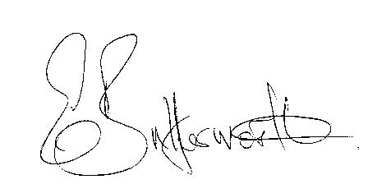Clerk

BUSINESS TO BE TRANSACTED

- Record of Members present.
- To receive apologies and approve reasons for absence.
- To receive written requests for Disclosable Pecuniary Interests or Non-Pecuniary interests where that interest is not already in the register of members’ interests.
- To approve the minutes of the Parish Council meeting held on 12th September 2019.
- Public participation: To receive any questions or presentations from the public.
- County & District Councillors reports. For information only.
- Planning Matters – update on current planning matters.
To consider the following:
Planning Application No. 19/02444/FUL Walnut Tree Cottage: Demolition of lean-tos and garage/domestic outbuildings, erection of two storey side extension, erection of garage building, change of use of land from agricultural/paddock to domestic, closing up of existing vehicular access, reopening of former access and alterations to driveway.
Planning Application No. 19/02581/LBC Pheasant Barn, Shelfield: Replacement of external doors and windows, internal reconfiguration and alterations to modern doors and partitions, alteration of the rear elevation to allow the installation of 2 glazed doors.
- Progress reports – for information only and are items not on the agenda.
- Correspondence received:
- Community Messaging Live Feed Invite to Cake Not Hate event in Leamington Spa 19th
October 2019.
- Applications are now being accepted for 2nd round of County Cllrs. Grant Fund
- Government consultation regarding %G telephone masts
- Mayor’s Music Party Night 26th October 2019.
- Notification of WALC Annual General meeting 9th November 2019.
- WRCC advisory on number of completed forms returned
10. Lengthsman scheme – items requiring attention.
11. Decision on plans and events for the next twelve months.
12. Inventory of assets – findings.
13. Village Hall update.
14. Councillors’ reports and items for the agenda for the next meeting.
15. Date of next meeting: 14th November 2019.

