Parish of Aston Cantlow

A meeting of the Parish Council for the above named Parish will be held on 10th November 2022 at 7.00 pm in Aston Cantlow Village Hall

Dated this 4th day of November 2022
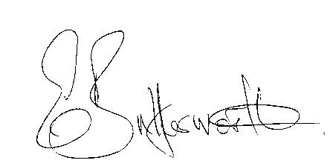Clerk

BUSINESS TO BE TRANSACTED

- Record of Members present.
- To receive apologies and approve reasons for absence.
- Declarations of interest in items on the agenda.
- To approve the minutes of the Parish Council meeting held on 29th September 2022.
- Public participation.
- Community Speedwatch.
- County & District Councillors’ reports.
- Planning applications: current status.
9. Vehicle Activated signs – update from County Cllr. Kerridge.

10. Draft Precept to be considered for approval in January meeting.

11. Bank Mandate – ratify consent from all new members to be added to the mandate.

12. Cllr Forman to stand down - Election of new Chairman.

13. Date of next meeting: 19th January 2023

