PARISH OF ASTON CANTLOW

NOTICE OF MEETING OF PARISH COUNCIL
Dear Sir/Madam

You are hereby summoned to attend a meeting of Aston Cantlow Parish Council to be held in the Guild Hall, Aston Cantlow on 11th April 2019, following the Annual Parish meeting, for the purpose of transacting the following business.

Dated this 5th day of April 2019

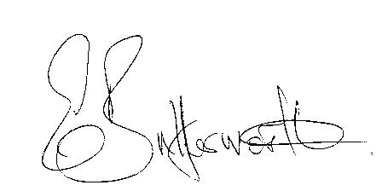

Clerk to the Parish Council

BUSINESS TO BE TRANSACTED

- Record of Members present.
- To receive apologies and approve reasons for absence.
- To receive written requests for Disclosable Pecuniary Interests or Non-Pecuniary interests where that interest is not already in the register of members’ interests.
- To approve the minutes of the parish council meeting held on 14th March 2019.
- Public participation: To receive any questions or presentations from the public.
- County & District Councillors reports. For information only. Unless known in advance items raised for a decision will appear on the next agenda.
- Planning Matters – update on current planning matters.
- Progress reports – for information only and are items not on the agenda.
- Correspondence received:
Concerns raised by a resident regarding the playground.
10. WRCC Housing Needs Survey
11. Councillors’ reports and items for the agenda for the next meeting.
12. Date of next meeting: 16th May 2019. Annual General meeting followed by ordinary Parish Council meeting.

Councillors are reminded of their duty to consider all aspects of equal opportunity, Crime prevention, unlawful discrimination, biodiversity of the natural habitat, and other best practice when making decisions at the meeting.

