Parish of Aston Cantlow

NOTICE OF MEETING OF

PARISH COUNCIL

NOTICE IS HEREBY GIVEN THAT

A Meeting of the Parish Council for the above named Parish will be held in the Guild Hall, Aston Cantlow on the 12th March 2020 at 7.30 p.m.

Dated this 5th day of March 2020
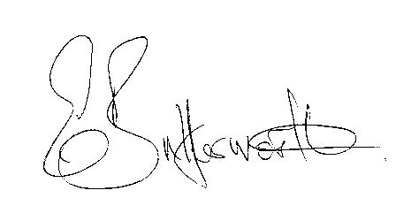Clerk

BUSINESS TO BE TRANSACTED

- Record of Members present.
- To receive apologies and approve reasons for absence.
- To receive written requests for Disclosable Pecuniary Interests or Non-Pecuniary interests where that interest is not already in the register of members’ interests.
- To approve the minutes of the Parish Council meeting held on 13th February 2020.
- Public participation: To receive any questions or presentations from the public.
- County & District Councillors reports. For information only.
- Planning Matters – update on current planning matters.
To consider planning application Nos. 20/00456/FUL and 20/00457/LBC The Old School House, Aston Cantlow: Repair of two chimney stacks in accordance with structural engineer’s report and guidance.
- Progress reports – for information only and are items not on the agenda.
- Correspondence received:
- Survey: Community Safety in Warwickshire
- Details of the Campaign for the Local Electricity Bill
- Consultation Day with Warwickshire County Council
- Advance details of date for Three Tier Event – 16th July and the theme is Climate Change
- Invitation to the Mayor’s end of year quiz on 17th April 2020.
10. Risk Assessment.
11. Pools Barn Farm Traffic Management Plan.
11. Village Hall update.
12. Councillors’ reports and items for the agenda for the next meeting.
13. Date of next meeting: 9th April 2020.

