PARISH OF ASTON CANTLOW

NOTICE OF MEETING OF PARISH COUNCIL
Dear Sir/Madam

You are hereby summoned to attend a meeting of Aston Cantlow Parish Council to be held in the Guild Hall, Aston Cantlow on 12th September 2019 at 7.30 p.m., for the purpose of transacting the following business.

Dated this 5th day of September 2019

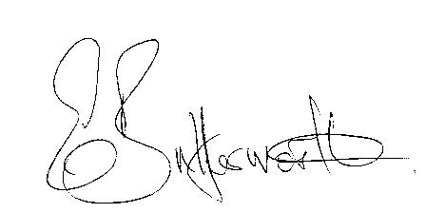

Clerk to the Parish Council

BUSINESS TO BE TRANSACTED

- Record of Members present.
- To receive apologies and approve reasons for absence.
- To receive written requests for Disclosable Pecuniary Interests or Non-Pecuniary interests where that interest is not already in the register of members’ interests.
- To approve the minutes of the Parish Council meeting held on 11th July 2019.
- Public participation: To receive any questions or presentations from the public.
- County & District Councillors reports. For information only.
- Planning Matters – update on current planning matters.
To consider Planning Application No. 19/02365/TREE Aston Cantlow Working Mens Club: Sycamore, cut ivy at 1.5m, remove basal growth including three larger stems on West side of stem. Crown lift to 5m
- Progress reports – for information only and are items not on the agenda.
- Correspondence received:
- Alcester South SNT flyer.
- Advisory. 8th May 2020 will be a Bank Holiday to celebrate the 75th Anniversary of VE Day.
- Notice of Modification Order AL223.
- UBUS Service letter.
- Advance notice of road closure on 6th October for the SECO Alcester 10k.
- Brain Tumour Research - Walk of Hope details.
10. Lengthsman scheme update. Details of any outstanding works.
11. Site Allocations Plan. Report from attendees at SDC event. Responses to Site Allocations Plan
Consultation.
12. Future plans and possible events for this year.
13. To consider management of Grants/Donations going forward.
14. Inventory of assets – update
15. Communications update.
16. Village Hall update.
17. Councillors’ reports and items for the agenda for the next meeting.
18. Date of next meeting: 10th October 2019.

Councillors are reminded of their duty to consider all aspects of equal opportunity, Crime prevention, unlawful discrimination, biodiversity of the natural habitat, and other best practice when making decisions at the meeting.

