Parish of Aston Cantlow

NOTICE OF MEETING OF

PARISH COUNCIL

NOTICE IS HEREBY GIVEN THAT

A Meeting of the Parish Council for the above named Parish will be held on the 12th November 2020 at 7.30 p.m.

For the health and well-being of our community as a result of the Covid-19 crisis and following the instruction of the Prime Minister’s address on 23rd March 2020, all Parish Council meetings will be held remotely until further notice using Zoom software.

Should any resident wish to submit a question to the Parish Council or to participate in the meeting via Zoom, please email the Clerk lizbutterworth1@btinternet.com by 2 pm on Tuesday 9th November.

Dated this 5th day of November 2020
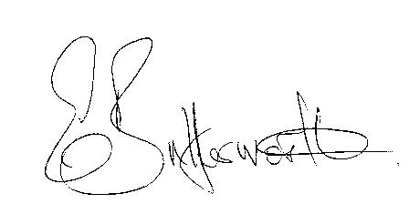Clerk

BUSINESS TO BE TRANSACTED

- Record of Members present.
- To receive apologies and approve reasons for absence.
- To receive written requests for Disclosable Pecuniary Interests or Non-Pecuniary interests where that interest is not already in the register of members’ interests.
- To approve the minutes of the Parish Council meeting held on 8th October 2020.
- Public participation: To receive any questions or presentations from the public.
- County & District Councillors reports.
- Planning Matters: To consider planning application No. 20/02950/TREE The Old Forge, Bearley Road, Aston Cantlow: Various tree works.
- Correspondence received: All correspondence sent electronically to date will be taken as read.
- Draft Precept for consideration and final approval in January 2021.
- Concern expressed regarding the number of cars parked on the village green at the junction of Bearley Rod, and Chapel Lane.
- To consider frequency of meetings.
- Lengthsman - works considered necessary by a Lengthsman in the parish.
13. Date of next meeting: to be advised.

