Parish of Aston Cantlow

NOTICE OF MEETING OF

PARISH COUNCIL

NOTICE IS HEREBY GIVEN THAT

A Meeting of the Parish Council for the above named Parish will be held in the Guild Hall, Aston Cantlow on the 13th February 2020 at 7.30 p.m.

Dated this 7th day of February 2020
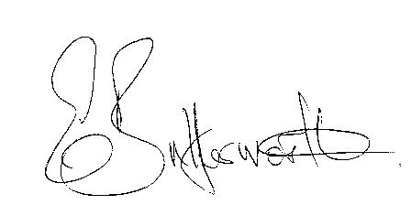Clerk

BUSINESS TO BE TRANSACTED

- Record of Members present.
- To receive apologies and approve reasons for absence.
- To receive written requests for Disclosable Pecuniary Interests or Non-Pecuniary interests where that interest is not already in the register of members’ interests.
- To approve the minutes of the Parish Council meeting held on 16th January 2020.
- Public participation: To receive any questions or presentations from the public.
- County & District Councillors reports. For information only.
- Planning Matters – update on current planning matters.
- Progress reports – for information only and are items not on the agenda.
- Correspondence received:
- CSW Broadband News
10. Risk Assessment.
11. Village Hall update.
12. Councillors’ reports and items for the agenda for the next meeting.
13. Date of next meeting: 12th March 2020.

