Parish of Aston Cantlow

A meeting of the Parish Council for the above named Parish will be held on 13th July 2023 in Aston Cantlow Village Hall
at 7.00 pm

Dated this 7th day of July 2023
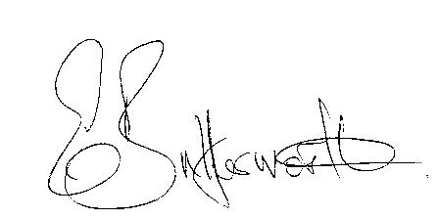Clerk

BUSINESS TO BE TRANSACTED

- Record of Members present.
- To receive apologies and approve reasons for absence.
- Declarations of interest in items on the agenda.
- Sarah Brooke-Taylor, WRCC, to discuss housing needs survey and site canvassing.
- To approve the minutes of the Annual Parish Council meeting and ordinary meeting held on 18th May 2023
- Public participation.
- Community Speedwatch/Traffic Calming.
- County & District Councillors’ reports.
- Planning applications update.
- Update regarding the stile at Little Alne
11. Preparation of newsletters and monthly reports for publication.

12. Review of Parish Plan

13. Mill Lane speed reduction.

14. Review/update of Website.

15. Update on matters since the previous meeting.

16. Urgent items not on the agenda raised by Councillors.

17. To propose other items of business for consideration at the next meeting.

18. Bank Mandate.

19. Date of next meeting: 14th September 2023.

