Parish of Aston Cantlow

A meeting of the Parish Council for the above named Parish will be held on 14th March 2024 in Aston Cantlow Village Hall at 7.00pm

Dated this 9th day of March 2024
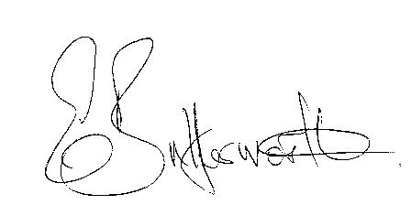Clerk

ANNUAL PARISH ASSEMBLY TO BE RE-SCHEDULED

BUSINESS TO BE TRANSACTED
- Election of Chair
- To receive apologies and approve reasons for absence.
- Declarations of interest in items on the agenda.
- To approve the minutes of the Parish Council meeting held on the 18th January 2024.
- To consider requests from Ms. Leedham, Mr. R. Mason and Mr P. Walters to be co-opted onto the Council. There are currently two vacant seats.
- Public participation.
- Correspondence: All correspondence circulated electronically is taken as read
- County & District Councillors’ reports.
9. Planning applications update.
10. WCC Rights of Way Improvement Plan – public footpaths survey.
11. Dog bin by Lych Gate.
12. Request received for pole markers to be fixed alongside the brook in Little Alne.
13. Flooding- CSW Resilience Team and County Council Flood Risk Team contacted.
14. D.Day 80th Anniversary.
15. Communication routes to residents.
16. Update on matters since the previous meeting:
- Mill Lane traffic safety provisions.
- WRCC Housing Needs Scheme.
- Defibrillator for Little Alne
- Review/update of Website.
17. Urgent items not on the agenda raised by Councillors.
18. To propose other items of business for consideration at the next meeting.
19. Date of next meeting: 9th May 2024. Annual Parish Council meeting followed by an
ordinary parish council meeting.

