Parish of Aston Cantlow

NOTICE OF MEETING OF

PARISH COUNCIL

NOTICE IS HEREBY GIVEN THAT

A Meeting of the Parish Council for the above named Parish will be held in the Guild Hall, Aston Cantlow on the 15th November 2018 at 7.30 p.m.

Dated this 8th day of November 2018
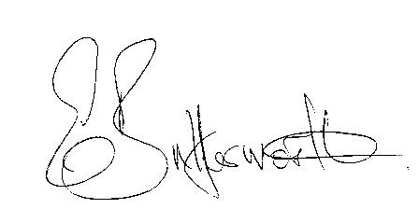Clerk

BUSINESS TO BE TRANSACTED

- Record of Members present.
- To receive apologies and approve reasons for absence.
- To receive written requests for Disclosable Pecuniary Interests or Non-Pecuniary interests where that interest is not already in the register of members’ interests.
- To approve the minutes of the parish council meeting held on 6th September 2018.
- Public participation: To receive any questions or presentations from the public.
- County & District Councillors reports. For information only. Unless known in advance items raised for a decision will appear on the next agenda.
- Planning Matters – update on current planning matters.
To consider planning application Nos. 18/02801/FUL and 18/02807/LBC Cantella Farm, Bearley Road, Aston Cantlow: Removal and replacement of existing brick boundary wall.
- Progress reports – for information only and are items not on the agenda.
- Correspondence received:
- Draft Statement of Community Involvement – consultation.
- D5349 Shelfield Green Lane, Burford - Road Closure now cancelled.
- WALC Community Grant Fund – limited to 20% of a project cost.
- Resident expressing concerns about the ditch/brook in Brook Road being badly overgrown.
- Illustrated Parish Maps promotion.
- Notification of adoption of the Canal Quarter SPD.
- Civic Service on Sunday 23 September 2018 at St Nicholas Church Alcester.
- Notification that WALC Community Grant Fund is open to bids.
- Chairman's Festive Open Evening Saturday, 1st December 2018.
- Councils VASA funding bid.
- Alcester Town Council- Save the date- Civic Dinner 2019.
- Temporary closure of B4089 Alcester Road, Little Alne 1st to 3rd December 2018.
10. Draft Precept 2019/2020
11. Traffic speeds through Little Alne.
12. Councillors’ reports and items for the agenda for the next meeting. Cllrs. are reminded that this is not an opportunity for decision making.
13. Date of next meeting: 10th January 2019.

