Parish of Aston Cantlow

NOTICE OF MEETING OF

PARISH COUNCIL

NOTICE IS HEREBY GIVEN THAT

A Meeting of the Parish Council for the above named Parish will be held in the Guild Hall, Aston Cantlow on the 16th January 2020 at 7.30 p.m.

Dated this 9th day of January 2020
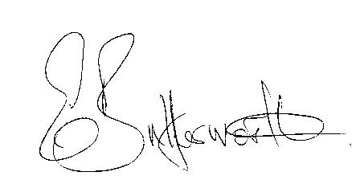Clerk

BUSINESS TO BE TRANSACTED

- Record of Members present.
- To receive apologies and approve reasons for absence.
- Presentation providing information on the Parenting Project by Elaine Johnston.
- To receive written requests for Disclosable Pecuniary Interests or Non-Pecuniary interests where that interest is not already in the register of members’ interests.
- To approve the minutes of the Parish Council meeting held on 10th October 2019.
- Public participation: To receive any questions or presentations from the public.
- County & District Councillors reports. For information only.
- Planning Matters – update on current planning matters.
- Progress reports – for information only and are items not on the agenda.
- Correspondence received:
- Bearley NDP Regulation 16 Submission Consultation.
- District & Parish Councillors Weekly information.
- Heart of England update on planting plans for Newnham.
- Developing Stroke Services in Coventry & Warwickshire.
- Police Precept Consultation.
- SDC Notice of Proposed New Bylaw.
- Details of Severn Trent Community Fund.
- Advisory of closure of Mill Lane 20th -22nd January 2020.
- WALC Newsletter – Training Special
11. Agree final Precept for 2020/21.
12. WRCC Housing Needs Survey report for adoption.
13. Risk Assessment.
14. Village Hall update.
15. Councillors’ reports and items for the agenda for the next meeting.
16. Date of next meeting: 13th February 2020.

