Parish of Aston Cantlow

A meeting of the Parish Council for the above named Parish will be held on 16th March 2023 in Aston Cantlow Village Hall
following the Parish Council Annual Assembly

Dated this 10th day of March 2023
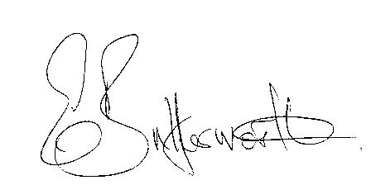Clerk

BUSINESS TO BE TRANSACTED

- Record of Members present.
- To receive apologies and approve reasons for absence.
- Declarations of interest in items on the agenda.
- To approve the minutes of the Parish Council meeting held on 19th January 2023.
- Public participation.
- Community Speedwatch/Traffic Calming.
- County & District Councillors’ reports.
- Planning applications update.
9. Preparation of newsletters/reports for publication.

10. Update on matters reported by Councillors at the previous meeting.

11. Urgent items not on the agenda raised by Councillors.

12. To propose other items of business for consideration at the next meeting.

13. Election packs.

14. Date of next meeting: 18th May 2023. Annual Parish Council meeting followed by ordinary
Parish Council meeting.

