Parish of Aston Cantlow

NOTICE OF MEETING OF

PARISH COUNCIL

NOTICE IS HEREBY GIVEN THAT

A Meeting of the Parish Council for the above named Parish will be held in the Guild Hall, Aston Cantlow on the 16th May 2019 following the Annual General meeting

Dated this 9th day of May 2019
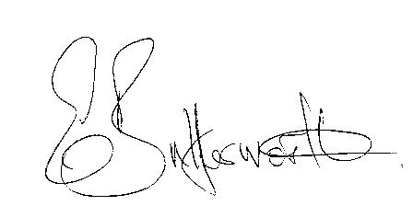Clerk

BUSINESS TO BE TRANSACTED

- Record of Members present.
- To receive apologies and approve reasons for absence.
- To receive written requests for Disclosable Pecuniary Interests or Non-Pecuniary interests where that interest is not already in the register of members’ interests.
- To approve the minutes of the Annual Parish meeting and ordinary parish council meeting held on 11th April 2019.
- Public participation: To receive any questions or presentations from the public.
- County & District Councillors reports. For information only.
- Planning Matters – update on current planning matters.
- Progress reports – for information only and are items not on the agenda.
- Correspondence received:
Mobile Library confirmation that they will be parking in Bearley Road.
Notification of County Councillors Grant Fund 2019/20.
Royal Marines Association Concert Band 26th May 2019.
Road Closure of Burford Lane, Aston Cantlow 3rd – 6th June 2019.
10. Annual Accounts of Aston Cantlow Parish Council 2018/19.
11. WRCC Housing Needs Survey.
12. Councillors’ reports and items for the agenda for the next meeting.
13. Date of next meeting: 13th June 2019.

